**Library Management System**

**Project Report**

*Submitted in fulfilment for the JComponent of ITA – 3006-Java programming*

**CAL Course**

***in***

**B.C.A**

*by*

**G.K.LOSHMIN (18BCA0112)**

**R.JOTHIKA (18BCA0123)**

*Under the guidance of*

**Dr. Charanya.R**

**SITE**



**School of Information Technology and Engineering**

**Winter Semester 2019-2020**

**Abstract:**

Library management system is a project which aims in developing a computerized system to maintain all the daily work of library .This project has many features which are generally not availiable in normal library management systems like facility of user login and a facility of teachers login .It also has a facility of admin login through which the admin can monitor the whole system .It also has facility of an online notice board where teachers can student can put up information about workshops or seminars being held in our colleges or nearby colleges and librarian after proper verification from the concerned institution organizing the seminar can add it to the notice board . It has also a facility where student after logging in their accounts can see list of books issued and its issue date and return date and also the students can request the librarian to add new books by filling the book request for me. The librarian after logging into his account admin account can generate various reports such as student report , issue report, teacher report and book report Overall this project of ours is being developed to help the students as well as staff of library to maintain the library in the best way possible and also reduce the human efforts.

Management is a problem in the manual library thereby causing inefficiency and time consuming in the library. Also the problem of space consuming erupts after the number of records become large the space for physical storage of file and records also increases if no computerized system is implemented as well as the issue of cost .Due to problem of lack of prompt information retrieval and time wastage in using the library. In addition due to the cumbersome, in this project computer approach will be used to solve these problems. Each of the manual procedure will be analysed.

**LITERATURE SURVEY**

|  |  |  |  |
| --- | --- | --- | --- |
| **SNO** | **TITLE** | **FEATURES** | **LIMITATION** |
| 1. | Part library-based information retrieval and inspection framework to support part maintenance using 3D printing technology Kim, H., Cha, M., Kim, B. C., Kim, T., & Mun, D. (2019). Part library-based information retrieval and inspection framework to support part maintenance using 3D printing technology. *Rapid Prototyping Journal*, *25*(3), 630-644. | The purpose of this study is the use of 3D printing technology to perform maintenance on damaged parts on site.  To maintain damaged parts, the user needs experience in the parts design and 3Dprinting technology. | 3d printer technology have small print chamber which restrict the size of part that can be printed we need large size  3d printer allows for the fast production of parts the speed of manufactutre can be slowed by post processing |
| 2. | Media and drive validation in a storage library     Kim, Hyoungjin, Alexander Edward Amador, and Stephanie Lynn Russell. "Media and drive validation in a storage library." U.S. Patent Application 10/303,377, filed May 28, 2019. | Systems and methods for validating storage media and/or media drives in a storage library using a hidden drive pool and a non-hidden media pool    A storage library can be instructed to perform media/drive validation (MDV) on a selected pool of physical storage media using a selected pool of drive resources. | Instructing the storage library to move at least one of the selected set of storage media to one of the selected set of media drive resources; and instructing the one of the selected set of media drive resources to execute a media/drive validation using the at least one of the selected set of storage media.  If the storage library and/or its users can maintain awareness of which storage media and/or media drives are more or less reliable, |
| 3. | Library control device and library control method for removing malfunctioning media. Naoto OO, inventor; NEC Platforms Ltd, assignee. Library control device and library control method for removing malfunctioning media from magazine by rewriting its slot position. United States patent application US 10/276,205. 2019 Apr 30. | The library control device stores identifications of record media in correlation with slots loading recording media.  It is possible for an operator to extract the record medium detecting a malfunction from the predetermined slot without making any mistake | To reduce an execution time for an inventory operation by executing an inventory operation for part of slots being drawn out from a magazine.  The host computer retrieves data read from record media in the library device and provides the library device with data to be recorded on record media. |
| 4. | Integrated Library Management Systems Oshana, R., & Kraeling, M. (Eds.). (2019). integrated library management system *practical techniques, and applications*. Newnes. | The development of Integrated Library Management Systems, and look at some broad trends in their development. More and more core functions and special features have been integrated into library systems, and there has been a move towards industry standard databases, operating systems and architecture.    The second part of the article looks at more aspirational library system designs, that reflect libraries' new needs in the light of the electronic. publishing revolution and the open source software movement. | The data stored is prone to cyber hacks. Opting for a reliable online system eliminates the risk.Online Systems require high-speed internet connectivity.  Complicated to operate.Risk of computer virus.  The automation feature is not available in offline/ open source systems thus, requires manual action to performoperations.Unlike online systems that utilizecloud computing, Open-source systems |
| 5. | Using cloud serivce for library system.  Dalessio M, Smith J, Shahid J, Wen J, Jahn D, Goddard DE, Eckhardt F, Kropf MW, Bayer JT, Shroyer B, Gerritz K, inventors. Library scan for live applications. United States patent application US 10/229,251. 2019 Mar 12. | Libraries are in a unique position to experiment with cloud computing given their service-oriented mission and need to find appropriate solutions using limited resources  The observes that one of the key pressures that both pushes libraries to cloud solutions and proves to be an impediment to the migration is the availability of support services | libraries have become automated which is the  basic need towards advancement followed by network  s and more effort are towards virtual libraries.    The later technology trend in library science is use of cloud  computing for various purposes and for achieving economy in library functions |
| 6. | Methods and systems for creating and maintaining a library of virtual hard disks  Jain, Parul K. "Methods and systems for creating and maintaining a library of virtual hard disks." U.S. Patent Application 10/282,092, filed May 7, 2019. | Methods and systems for creating and maintaining a virtual library of virtual hard disks involve one or more processors partitioning resources on a physical host computer into at least one virtual machine having at least one virtual hard disk attached to the virtual machine and loading pre-selected custom content on the virtual hard disk.  The cataloged virtual hard disk loaded with the pre-selected custom content may be attached from the database to the virtual machine on the physical host computer. | A problem with such an arrangement is that it takes considerable time and effort, to set up a virtual computer exactly the way a user may want it to work.    They or other users can use to create new virtual machines such that the customization effort is minimized. |
| 7. | Data storage library with pass-through connected media. Gavillan, Jose G. Miranda, Brian G. Goodman, and Kenny Nian Gan Qiu. "Data storage library with pass-through connected media acclimation chamber." U.S. Patent No. 10,303,376. 28 May 2019. | A data storage library system includes a first data storage library and a second data storage library, and at least one pass-through mechanism coupling the first data storage library to the second data storage library.  The environmental conditions within the first data storage library are controllable to maintain operational conditions conducive to at least one of reading and writing of data on a plurality of data storage cartridges. | The is not normally an issue for backups of file servers and workstations, as the larger, more time-consuming full backups can usually run in the background for a longer period without any ill effects.    To ensure you don’t saturate your internet connection during times when access to the internet is needed for other critical business activity. |
| 8. | Marketing academic library information services using social media  AlAwadhi, Suha, and Sultan M. Al-Daihani. "Marketing academic library information services using social media." *Library Management* 40.3/4 (2019): 228-239. | This study provides insights into the factors related to the use of modern social media platforms to promote information resources and services at academic libraries to provide outreach services to current and potential users.  libraries to interact with patrons through discussion boards and walls, image tagging, andcomments.Ultimately, social networking sites allow libraries to promote their services in a different venue. | Particularly elderly users, will not be reached by such efforts. Some libraries also face problems using social networking sites because library filters can block them.  This reveals potential limitations for libraries using social networking tools. Ultimately, any library looking at using social networking tools |
| 9. | A library of building occupant behaviour models represented Belafi, Zsofia Deme, Tianzhen Hong, and Andras Reith. "A library of building occupant behaviour models represented in a standardised schema." *Energy Efficiency* 12.3 (2019): 637-651. | A large number of data-driven behavioural models have been developed based on field data  Each library within the system concentrates on the needs of the members of a specific department or field of study, and the quality of the library is defined in terms of the strengths of the research collection. | The identification of materials wanted is often confusing and comprehensible until the user is actually shown how the system works.  Reference encounters with undergraduates often result not only in answering specific questions. |
| 10. | Quality management for today’s academic library Miller, Rush G., and Beverly Steams. "Quality management for today’s academic library." *College & research libraries news* 55.7 (2019): 406-422. | The organization focuses its resources on meeting the needs of “customers,” both internal  The goal of the organization is to improve the quality of services processes on a continual basis as opposed to major innovation and change. | It take time to provides a method of improving services to users in a period of limited resources.    Decremental changes lead to continuous improvement—quick solutions may yield only partial results. |
| 11. | A checklist for evaluating open source digital library software Goh, Dion Hoe‐Lian, et al. "A checklist for evaluating open source digital library software." *Online Information Review* (2019). | Many open source software packages are  available  for organizations and individuals to create digital libraries . | EPrints was the worst performer due to  poor support for certain features deemed important in our checklist, and a total absence of functionality in other categories. |
| 12. | Digital information library and delivery system  Katz, D.R., Lau, E.J., Mott, T., Brenneman, S.A., Jun, B.C.M. and Pai, S.H.Y., Audible Inc, 2019. *Digital information library and delivery system with the playback device*. U.S. Patent 5,926,624. | A library server having a plurality of digital information files.a mobile device. removably connectable to the client computer system.library server having a plurality of digital information files; | Interfaces, and processes have not been shown in detail in order not to unnecessarily obscure the present invention. |
| 13. | Method and apparatus for creating a searchable digital video library and a system and method of using such a library . Wactlar, H. D., Kanade, T., Mauldin, M. L., Reddy, D. R., Stevens, S. M., Christel, M. G., & Smith, M. A. (2019). *U.S. Patent No. 5,835,667*. Washington, DC: U.S. Patent and Trademark Office | The method also includes the step of passing the transcribed audio data through a natural language interpreted  before indexing the transcribed audio data. | There are many problems and challenges presented by the audio portion of raw videotaped footage which must  be addressed by any digital library system. |
| 14. | Marketing of library services Kavulya, Joseph Muema. "Marketing of library services: a case study of selected university libraries in Kenya." *Library management* (2019). | This requires a shift from product or service orientation to customer or need orientation. Different marketing concepts provide libraries with the tools for collecting and analysing useful data about information needs of customers | More emphasis must be put on promotion of the already existing services  to design and deliver services that fit user requirements. |
| 15. | The library as a learning organization Rowley, Jennifer. "The library as a learning organization." *Library Management* 18.2 (2019) | The need for libraries to become learning organizations to enable them to survive by responding appropriately to change | There is no cookbook recipe for creating a learning organization but identifies some of the necessary conditions, underlines the importance of individual learners in building a learning organization |
| 16. | End-user satisfaction analysis on library management system  W Hardyanto1, A Purwinarko2and M A Adhi11Department of Physics, FMIPA, Universitas Negeri Semarang2Department of Computer Science, FMIPA, Universitas Negeri Semarang*Corresponding author: 2019 | Library information systems as organizational support are expected to provide fast and accurate service to users | Many obstacles that are still a homework for libraries, it affects the level of user visits to libraries and data accountability |
| 17. | Development of integrated library automation system:  Universitas Negeri Department of Computer Science, Faculty of Mathematics And Natural Sciences, Universitas Negeri Semarang, Indonesia2 Department of  Physics, Faculty of  Mathematics And Natural Sciences Semarang, Indonesia  Published on 2019. | In this Acquisitions function asgenerate Purchase order, Cancel Purchase Order , Reminder Purchase order ,Receive Purchase Order , Invoice and instantlyavailable in Reports . Data can besearch by feeding  Purchase Order number, Invoice number, and Supplier name | Many obstacles that must be unsolved are mainly related to the design, speed, and accuracy when accessing information, as well as the completeness of the data. |

|  |  |  |  |  |
| --- | --- | --- | --- | --- |
| 18. | International Conference on Library and Information Science  Kuo Li, Shih Chien Science https:// iconlis.org Chien University, Taiwan Proceedings of the International Conference on Library and Information Science, ISSN 2412-0049, Vo l . 5 , No. 1, January 2019 Published by International Business Academics Consortium,Taipei,Taiwan | | system developed was aimed at allowingusers to reserve books via online, to convenient user borrowing books via  online,implementing email technologies to the website, implementing SMS technologies to thesystem, designing a friendly graphical interface which would suit the users. | Discharging functions of the circulation section Less effectively which provide various search options to know the availability of books in the library to generate the list of books due by a particular member and also the overdue charges |
| 19. | | Library Studies, Department of Engineering,  Vocational Faculty, Universitas Airlangga, Surabaya, Indonesia*Corresponding author: *Dessy Harisanty: Library Studies, Department of Engineering, Vocational Faculty, Universitas Air-langga, Surabaya, Indonesia*Corresponding author E-mail: [dessyharisanty@gmail.com](mailto:dessyharisanty@gmail.com) | One can customize the system to feel easier for data entry also whileadding records user can keep form in 'add' mode. Define Holidays. And Set thecriteria of issuing the book if member is requested for media or not | Lack productivity and job satisfaction among staff members as it eliminates duplication of effort |
| 20. | | The 21st Century Library and Information Services Idiegbeyan-ose, Jerome,  Promise Ilo, and Chidi Isiakpona. "The 21st century library and information services for the enhancement of teacher education." *Pre-Service and In-Service Teacher Education: Concepts, Methodologies, Tools, and Applications*. IGI Global, 2019. 1899-1913. | They include multi-user access to resources, improvemen tof internal operations,  round-the-clock access  as well as back-up power supplies for better performance of these libraries. | 21st century Library and Information Services should therefore not be trivialized in any way. |

**REFERENCES :**

### [The 21st century library and information services for the enhancement of teacher education](https://www.igi-global.com/chapter/the-21st-century-library-and-information-services-for-the-enhancement-of-teacher-education/215648)

[J Idiegbeyan-ose](https://scholar.google.com/citations?user=QjkGhfAAAAAJ&hl=en&oi=sra), [P Ilo](https://scholar.google.com/citations?user=emqXpQsAAAAJ&hl=en&oi=sra), [C Isiakpona](https://scholar.google.com/citations?user=N05H5AkAAAAJ&hl=en&oi=sra) - Pre-Service and In-Service …, 2019 - igi-global.com

### [Part library-based information retrieval and inspection framework to support part maintenance using 3D printing technology](https://www.emeraldinsight.com/doi/abs/10.1108/RPJ-06-2018-0139)

[H Kim](https://scholar.google.com/citations?user=0Twj2DkAAAAJ&hl=en&oi=sra), [M Cha](https://scholar.google.com/citations?user=GitAjLoAAAAJ&hl=en&oi=sra), [BC Kim](https://scholar.google.com/citations?user=h3ajsn0AAAAJ&hl=en&oi=sra), T Kim… - Rapid Prototyping …, 2019 - emeraldinsight.com

### [Media and drive validation in a storage library](https://patents.google.com/patent/US10303377B2/en)

H Kim, AE Amador, SL Russell - US Patent App. 10/303,377, 2019 - Google Patents

### [Library control device and library control method for removing malfunctioning media from magazine by rewriting its slot position](https://patents.google.com/patent/US10276205B2/en)

O Naoto - US Patent App. 10/276,205, 2019 - Google Patents

### [Open source integrated library systems migration: Librarians share the lessons learnt](https://journals.sagepub.com/doi/abs/10.1177/0961000617709059)

[V Singh](https://scholar.google.com/citations?user=xdJqYcsAAAAJ&hl=en&oi=sra) - Journal of Librarianship and Information Science, 2019 - journals.sagepub.com

**CODE IMPLEMENTATION**

**HOME PAGE:**

package log;

import java.awt.BorderLayout;

import java.awt.EventQueue;

import java.awt.image.*;

import javax.swing.ImageIcon;

import javax.swing.JFrame;

import javax.swing.JPanel;

import javax.swing.border.EmptyBorder;

import java.awt.Color;

import javax.swing.JLabel;

import java.awt.Font;

import java.awt.Image;

import javax.swing.JButton;

import java.awt.event.ActionListener;

import java.awt.event.ActionEvent;

public class home extends JFrame

{

private JPanel contentPane;

/**

* Launch the application.

*/

public static void main(String[] args) {

EventQueue.invokeLater(new Runnable() {

public void run() {

try {

home frame = new home();

frame.setVisible(true);

} catch (Exception e) {

e.printStackTrace();

}

}

});

}

/**

* Create the frame.

*/

public home() {

setDefaultCloseOperation(JFrame.EXIT_ON_CLOSE);

setBounds(100, 100, 854, 487);

contentPane = new JPanel();

contentPane.setBackground(new Color(255, 255, 255));

contentPane.setBorder(new EmptyBorder(5, 5, 5, 5));

setContentPane(contentPane);

contentPane.setLayout(null);

JPanel panel = new JPanel();

panel.setBackground(new Color(0, 0, 0));

panel.setBounds(10, 11, 818, 76);

contentPane.add(panel);

panel.setLayout(null);

JLabel lblNewLabel = new JLabel

(" LIBRARY MANAGEMENT SYSTEM");

lblNewLabel.setForeground(new Color(255, 255, 255));

lblNewLabel.setFont(new Font

("Times New Roman", Font.BOLD,32));

lblNewLabel.setBackground(new Color(255, 255, 255));

lblNewLabel.setBounds(107, 11, 658, 54);

panel.add(lblNewLabel);

JPanel panel_1 = new JPanel();

panel_1.setBackground(new Color(0, 128, 128));

panel_1.setBounds(10, 98, 818, 339);

contentPane.add(panel_1);

panel_1.setLayout(null);

JButton btnNewButton = new JButton(" LOGIN");

btnNewButton.addActionListener(new ActionListener() {

public void actionPerformed(ActionEvent e) {

aulogin log = new aulogin();

log.setVisible(true);

}

});

btnNewButton.setBackground(new Color(255, 255, 255));

btnNewButton.setFont(new Font("Times New Roman", Font.BOLD, 18));

btnNewButton.setBounds(37, 11, 124, 23);

panel_1.add(btnNewButton);

JButton btnNewButton_1 = new JButton("SIGNIN");

btnNewButton_1.addActionListener(new ActionListener() {

public void actionPerformed(ActionEvent e) {

signup sin = new signup();

sin.setVisible(true);

}

});

btnNewButton_1.setFont(new Font("Times New Roman", Font.BOLD, 19));

btnNewButton_1.setBackground(new Color(255, 255, 255));

btnNewButton_1.setBounds(196, 11, 110, 23);

panel_1.add(btnNewButton_1);

JButton btnNewButton_2 = new JButton(" CONTACT US");

btnNewButton_2.addActionListener(new ActionListener() {

public void actionPerformed(ActionEvent e) {

contact co = new contact();

co.setVisible(true);

}

});

btnNewButton_2.setBackground(new Color(255, 255, 255));

btnNewButton_2.setFont(new Font("Times New Roman", Font.BOLD, 18));

btnNewButton_2.setBounds(495, 11, 159, 23);

panel_1.add(btnNewButton_2);

JButton btnNewButton_3 = new JButton("ABOUT");

btnNewButton_3.addActionListener(new ActionListener() {

public void actionPerformed(ActionEvent e) {

aboutus ab = new aboutus();

ab.setVisible(true);

}

});

btnNewButton_3.setFont(new Font("Times New Roman", Font.BOLD, 18));

btnNewButton_3.setBackground(new Color(255, 255, 255));

btnNewButton_3.setBounds(352, 11, 110, 23);

panel_1.add(btnNewButton_3);

JButton btnNewButton_4 = new JButton(" FAQ");

btnNewButton_4.setFont(new Font("Times New Roman", Font.BOLD, 18));

btnNewButton_4.setBounds(685, 11, 89, 23);

panel_1.add(btnNewButton_4);

JLabel lblNewLabel_1 = new JLabel(" ");

Image img = new ImageIcon(this.getClass().getResource("/homef.jpg")).getImage();

lblNewLabel_1.setIcon(new ImageIcon(img));

lblNewLabel_1.setBounds(163, 45, 507, 283);

panel_1.add(lblNewLabel_1);

}

}

LOGIN :

package log;

import java.awt.BorderLayout;

import java.awt.EventQueue;

import javax.swing.JFrame;

import javax.swing.JPanel;

import javax.swing.border.EmptyBorder;

import java.awt.Color;

import javax.swing.JLabel;

import java.awt.Font;

import javax.swing.JButton;

import java.awt.event.ActionListener;

import java.awt.event.ActionEvent;

public class aulogin extends JFrame {

private JPanel contentPane;

private final JPanel panel = new JPanel();

/**

* Launch the application.

*/

public static void main(String[] args) {

EventQueue.invokeLater(new Runnable() {

public void run() {

try {

aulogin frame = new aulogin();

frame.setVisible(true);

} catch (Exception e) {

e.printStackTrace();

}

}

});

}

/**

* Create the frame.

*/

public aulogin() {

setDefaultCloseOperation(JFrame.EXIT_ON_CLOSE);

setBounds(100, 100, 827, 472);

contentPane = new JPanel();

contentPane.setBackground(new Color(255, 255, 255));

contentPane.setBorder(new EmptyBorder(5, 5, 5, 5));

setContentPane(contentPane);

contentPane.setLayout(null);

panel.setBackground(new Color(0, 0, 0));

panel.setBounds(10, 11, 791, 82);

contentPane.add(panel);

panel.setLayout(null);

JLabel lblNewLabel = new JLabel(" LOGIN PAGE");

lblNewLabel.setFont(new Font("Times New Roman", Font.BOLD, 28));

lblNewLabel.setForeground(new Color(255, 255, 255));

lblNewLabel.setBounds(301, 11, 202, 60);

panel.add(lblNewLabel);

JPanel panel_1 = new JPanel();

panel_1.setBackground(new Color(0, 128, 128));

panel_1.setBounds(10, 104, 791, 318);

contentPane.add(panel_1);

panel_1.setLayout(null);

JButton btnNewButton = new JButton(" ADMIN LOGIN");

btnNewButton.addActionListener(new ActionListener() {

public void actionPerformed(ActionEvent e) {

login al = new login();

al.setVisible(true);

}

});

btnNewButton.setFont(new Font("Times New Roman", Font.BOLD, 25));

btnNewButton.setBackground(new Color(255, 255, 255));

btnNewButton.setBounds(261, 48, 260, 56);

panel_1.add(btnNewButton);

JButton btnNewButton_1 = new JButton("USER LOGIN");

btnNewButton_1.setBackground(new Color(255, 255, 255));

btnNewButton_1.addActionListener(new ActionListener() {

public void actionPerformed(ActionEvent e) {

lreg ul = new lreg();

ul.setVisible(true);

}

});

btnNewButton_1.setFont(new Font("Times New Roman", Font.BOLD, 25));

btnNewButton_1.setBounds(261, 126, 260, 50);

panel_1.add(btnNewButton_1);

JButton btnNewButton_2 = new JButton(" BACK");

btnNewButton_2.addActionListener(new ActionListener() {

public void actionPerformed(ActionEvent e) {

home frame = new home();

frame.setVisible(true);

dispose();

}

});

btnNewButton_2.setForeground(new Color(255, 255, 255));

btnNewButton_2.setBackground(new Color(0, 0, 0));

btnNewButton_2.setFont(new Font("Times New Roman", Font.BOLD, 19));

btnNewButton_2.setBounds(330, 236, 141, 31);

panel_1.add(btnNewButton_2);

}

}

**USER LOGIN:**

**package log;**

import java.awt.EventQueue;

import javax.swing.JFrame;

import javax.swing.JFrame;

import java.awt.Color;

import javax.swing.JPanel;

import javax.swing.JLabel;

import javax.swing.JOptionPane;

import java.awt.Font;

import javax.swing.JTextField;

import javax.swing.JButton;

import java.awt.event.ActionListener;

import java.awt.event.ActionEvent;

import java.sql.*;

public class lreg extends JFrame {

private JTextField user;

private JTextField pass;

/**

* Launch the application.

*/

public static void main(String[] args) {

EventQueue.invokeLater(new Runnable() {

public void run() {

try {

lreg frame = new lreg();

frame.setVisible(true);

} catch (Exception e) {

e.printStackTrace();

}

}

});

}

/**

* Create the frame.

*/

public lreg() {

getContentPane().setBackground(new Color(255, 255, 255));

setBackground(new Color(255, 255, 255));

setBounds(100, 100, 844, 433);

setDefaultCloseOperation(JFrame.EXIT_ON_CLOSE);

getContentPane().setLayout(null);

JPanel panel = new JPanel();

panel.setBackground(new Color(0, 0, 0));

panel.setBounds(10, 11, 808, 69);

getContentPane().add(panel);

panel.setLayout(null);

JLabel lblNewLabel = new JLabel(" LOGIN PAGE");

lblNewLabel.setForeground(new Color(255, 255, 255));

lblNewLabel.setFont(new Font("Times New Roman", Font.BOLD, 30));

lblNewLabel.setBounds(276, 11, 312, 58);

panel.add(lblNewLabel);

JPanel panel_1 = new JPanel();

panel_1.setBackground(new Color(0, 139, 139));

panel_1.setBounds(10, 91, 808, 292);

getContentPane().add(panel_1);

panel_1.setLayout(null);

JLabel lblNewLabel_1 = new JLabel(" USERNAME");

lblNewLabel_1.setFont(new Font("Times New Roman", Font.BOLD, 20));

lblNewLabel_1.setBounds(203, 50, 116, 24);

panel_1.add(lblNewLabel_1);

JLabel lblNewLabel_2 = new JLabel(" PASSWORD");

lblNewLabel_2.setFont(new Font("Times New Roman", Font.BOLD, 20));

lblNewLabel_2.setBounds(203, 123, 116, 24);

panel_1.add(lblNewLabel_2);

user = new JTextField();

user.setBounds(427, 47, 162, 34);

panel_1.add(user);

user.setColumns(10);

pass = new JTextField();

pass.setBounds(427, 120, 162, 34);

panel_1.add(pass);

pass.setColumns(10);

JButton but = new JButton(" LOGIN");

but.addActionListener(new ActionListener() {

public void actionPerformed(ActionEvent e) {

try {

Class.forName("com.mysql.cj.jdbc.Driver");

Connection con = DriverManager.getConnection("jdbc:mysql://localhost:3306/userlogin","root","jothika");

Statement stmt = con.createStatement();

String sql ="Select * from ulogin where Username='"+user.getText()+"' and password = '"+pass.getText().toString()+"'";

ResultSet rs = stmt.executeQuery(sql);

if(rs.next())

{

JOptionPane.showMessageDialog(null,"login successfuly");

user usr = new user();

usr.setVisible(true);

}

else

JOptionPane.showMessageDialog(null,"invalid");

con.close();

}catch(Exception e1){

System.out.print(e);

}

}

});

but.setForeground(new Color(255, 255, 255));

but.setBackground(new Color(0, 0, 0));

but.setFont(new Font("Times New Roman", Font.BOLD, 20));

but.setBounds(279, 200, 222, 34);

panel_1.add(but);

JButton btnNewButton = new JButton(" BACK");

btnNewButton.addActionListener(new ActionListener() {

public void actionPerformed(ActionEvent e) {

aulogin frame = new aulogin();

frame.setVisible(true);

dispose();

}

});

btnNewButton.setForeground(new Color(255, 255, 255));

btnNewButton.setBackground(new Color(0, 0, 0));

btnNewButton.setFont(new Font("Times New Roman", Font.BOLD, 20));

btnNewButton.setBounds(575, 241, 127, 23);

panel_1.add(btnNewButton);

}

}

**ADMIN LOGIN:**

**package log;**

import java.awt.BorderLayout;

import java.awt.EventQueue;

import javax.swing.JFrame;

import javax.swing.JPanel;

import javax.swing.border.EmptyBorder;

import java.awt.Color;

import javax.swing.JLabel;

import javax.swing.JOptionPane;

import java.awt.Font;

import java.awt.Image;

import javax.swing.JTextField;

import javax.swing.ImageIcon;

import javax.swing.JButton;

import javax.swing.JPasswordField;

import java.awt.event.ActionListener;

import java.sql.Connection;

import java.sql.DriverManager;

import java.sql.ResultSet;

import java.sql.Statement;

import java.awt.event.ActionEvent;

public class login extends JFrame {

private JPanel contentPane;

private JTextField admin;

private JPasswordField pass;

/**

* Launch the application.

*/

public static void main(String[] args) {

EventQueue.invokeLater(new Runnable() {

public void run() {

try {

login frame = new login();

frame.setVisible(true);

} catch (Exception e) {

e.printStackTrace();

}

}

});

}

/**

* Create the frame.

*/

public login() {

setDefaultCloseOperation(JFrame.EXIT_ON_CLOSE);

setBounds(100, 100, 860, 475);

contentPane = new JPanel();

contentPane.setBorder(new EmptyBorder(5, 5, 5, 5));

setContentPane(contentPane);

contentPane.setLayout(null);

JPanel panel = new JPanel();

panel.setBackground(new Color(255, 255, 255));

panel.setBounds(0, 0, 844, 436);

contentPane.add(panel);

panel.setLayout(null);

JPanel panel_1 = new JPanel();

panel_1.setBackground(new Color(0, 128, 128));

panel_1.setBounds(10, 110, 824, 312);

panel.add(panel_1);

panel_1.setLayout(null);

JLabel lblNewLabel_1 = new JLabel(" ADMIN");

lblNewLabel_1.setFont(new Font("Times New Roman", Font.BOLD, 23));

lblNewLabel_1.setBackground(new Color(0, 0, 0));

lblNewLabel_1.setBounds(181, 68, 172, 40);

panel_1.add(lblNewLabel_1);

JLabel lblNewLabel_2 = new JLabel(" PASSWORD");

lblNewLabel_2.setFont(new Font("Times New Roman", Font.BOLD, 23));

lblNewLabel_2.setBounds(181, 167, 141, 28);

panel_1.add(lblNewLabel_2);

admin = new JTextField();

admin.setBounds(467, 75, 172, 34);

panel_1.add(admin);

admin.setColumns(10);

JButton btnNewButton = new JButton(" LOGIN");

btnNewButton.addActionListener(new ActionListener() {

public void actionPerformed(ActionEvent e) {

try {

Class.forName("com.mysql.cj.jdbc.Driver");

Connection con = DriverManager.getConnection("jdbc:mysql://localhost:3306/userlogin","root","jothika");

Statement stmt = con.createStatement();

String sql ="Select * from ulogin where Username='"+admin.getText()+"' and password = '"+pass.getText().toString()+"'";

ResultSet rs = stmt.executeQuery(sql);

if(rs.next())

{

JOptionPane.showMessageDialog(null,"login successfuly");

admin usr = new admin();

usr.setVisible(true);

}

else

JOptionPane.showMessageDialog(null,"invalid");

con.close();

}catch(Exception e1){

System.out.print(e);

}

}

});

btnNewButton.setForeground(new Color(255, 255, 255));

btnNewButton.setBackground(new Color(0, 0, 0));

btnNewButton.setFont(new Font("Times New Roman", Font.BOLD, 18));

btnNewButton.setBounds(291, 243, 179, 34);

panel_1.add(btnNewButton);

pass = new JPasswordField();

pass.setBounds(467, 168, 172, 34);

panel_1.add(pass);

JLabel logi = new JLabel("");

logi.setBounds(45, 34, 141, 68);

ImageIcon icon = new ImageIcon(this.getClass().getResource(""));

logi .setIcon(icon);

panel_1.add(logi);

JButton btnNewButton_1 = new JButton(" BACK");

btnNewButton_1.setForeground(new Color(255, 255, 255));

btnNewButton_1.setBackground(new Color(0, 0, 0));

btnNewButton_1.setFont(new Font("Times New Roman", Font.BOLD, 18));

btnNewButton_1.addActionListener(new ActionListener() {

public void actionPerformed(ActionEvent e) {

aulogin frame = new aulogin();

frame.setVisible(true);

dispose();

}

});

btnNewButton_1.setBounds(582, 251, 104, 23);

panel_1.add(btnNewButton_1);

JPanel panel_2 = new JPanel();

panel_2.setBackground(new Color(0, 0, 0));

panel_2.setBounds(10, 11, 824, 88);

panel.add(panel_2);

panel_2.setLayout(null);

JLabel lblNewLabel = new JLabel(" ADMIN LOGIN PAGE");

lblNewLabel.setForeground(new Color(255, 255, 255));

lblNewLabel.setBackground(new Color(255, 255, 255));

lblNewLabel.setEnabled(false);

lblNewLabel.setFont(new Font("Times New Roman", Font.BOLD, 28));

lblNewLabel.setBounds(262, 11, 327, 66);

panel_2.add(lblNewLabel);

}

}

**SIGNUP:**

**package log;**

import java.awt.BorderLayout;

import java.awt.EventQueue;

import javax.swing.JFrame;

import javax.swing.JPanel;

import javax.swing.border.EmptyBorder;

import java.awt.Color;

import javax.swing.JLabel;

import javax.swing.JOptionPane;

import java.awt.Font;

import javax.swing.JTextField;

import javax.swing.JTextPane;

import javax.swing.JPasswordField;

import javax.swing.JButton;

import java.awt.event.ActionListener;

import java.awt.event.ActionEvent;

import java.sql.*;

public class signup extends JFrame {

private JPanel contentPane;

private JTextField user;

private JTextField eid;

private JTextField mid;

private JTextField add;

private JPasswordField cpass;

private final JPasswordField pass = new JPasswordField();

/**

* Launch the application.

*/

public static void main(String[] args) {

EventQueue.invokeLater(new Runnable() {

public void run() {

try {

signup frame = new signup();

frame.setVisible(true);

} catch (Exception e) {

e.printStackTrace();

}

}

});

}

/**

* Create the frame.

*/

public signup() {

setBackground(new Color(255, 255, 255));

setDefaultCloseOperation(JFrame.EXIT_ON_CLOSE);

setBounds(100, 100, 865, 482);

contentPane = new JPanel();

contentPane.setBackground(new Color(255, 255, 255));

contentPane.setBorder(new EmptyBorder(5, 5, 5, 5));

setContentPane(contentPane);

contentPane.setLayout(null);

JPanel panel = new JPanel();

panel.setBackground(new Color(0, 0, 0));

panel.setBounds(10, 11, 829, 71);

contentPane.add(panel);

panel.setLayout(null);

JLabel lblNewLabel = new JLabel(" SIGN IN");

lblNewLabel.setForeground(new Color(255, 255, 255));

lblNewLabel.setFont(new Font("Times New Roman", Font.BOLD, 30));

lblNewLabel.setBackground(new Color(255, 255, 255));

lblNewLabel.setBounds(328, 11, 169, 49);

panel.add(lblNewLabel);

JPanel panel_1 = new JPanel();

panel_1.setBackground(new Color(0, 139, 139));

panel_1.setBounds(10, 93, 829, 339);

contentPane.add(panel_1);

panel_1.setLayout(null);

JLabel lblNewLabel_1 = new JLabel("USER NAME");

lblNewLabel_1.setFont(new Font("Times New Roman", Font.BOLD, 20));

lblNewLabel_1.setBounds(227, 11, 127, 24);

panel_1.add(lblNewLabel_1);

JLabel lblNewLabel_2 = new JLabel(" EMAIL ID");

lblNewLabel_2.setFont(new Font("Times New Roman", Font.BOLD, 20));

lblNewLabel_2.setBounds(227, 53, 101, 17);

panel_1.add(lblNewLabel_2);

JLabel lblNewLabel_3 = new JLabel(" MOBILE NO");

lblNewLabel_3.setFont(new Font("Times New Roman", Font.BOLD, 20));

lblNewLabel_3.setBounds(227, 94, 127, 24);

panel_1.add(lblNewLabel_3);

JLabel lblNewLabel_4 = new JLabel(" ADDRESS");

lblNewLabel_4.setFont(new Font("Times New Roman", Font.BOLD, 20));

lblNewLabel_4.setBounds(227, 136, 113, 24);

panel_1.add(lblNewLabel_4);

JLabel lblNewLabel_5 = new JLabel(" PASSWORD");

lblNewLabel_5.setFont(new Font("Times New Roman", Font.BOLD, 20));

lblNewLabel_5.setBounds(227, 191, 127, 24);

panel_1.add(lblNewLabel_5);

JLabel lblNewLabel_6 = new JLabel(" CON-PASSWORD");

lblNewLabel_6.setFont(new Font("Times New Roman", Font.BOLD, 20));

lblNewLabel_6.setBounds(232, 241, 167, 24);

panel_1.add(lblNewLabel_6);

user = new JTextField();

user.setBounds(432, 11, 134, 29);

panel_1.add(user);

user.setColumns(10);

eid = new JTextField();

eid.setBounds(431, 49, 135, 29);

panel_1.add(eid);

eid.setColumns(10);

mid = new JTextField();

mid.setBounds(432, 89, 134, 29);

panel_1.add(mid);

mid.setColumns(10);

add = new JTextField();

add.setBounds(432, 129, 134, 43);

panel_1.add(add);

add.setColumns(10);

cpass = new JPasswordField();

cpass.setBounds(430, 241, 136, 29);

panel_1.add(cpass);

JButton btnNewButton = new JButton(" SIGNIN");

btnNewButton.setBackground(new Color(0, 0, 0));

btnNewButton.setFont(new Font("Times New Roman", Font.BOLD, 20));

btnNewButton.addActionListener(new ActionListener() {

public void actionPerformed(ActionEvent e) {

try {

Class.forName("com.mysql.jdbc.Driver");

Connection con = DriverManager.getConnection("jdbc:mysql://localhost:3306/signup","root","jothika");

PreparedStatement ps = con.prepareStatement("insert into signup(username,emailid,mobile,address,password,cpassword) values(?,?,?,?,?,?);");

ps.setString(1, user.getText());

ps.setString(2, eid.getText());

ps.setString(3, mid.getText());

ps.setString(4, add.getText());

ps.setString(5, pass.getText());

ps.setString(6, cpass.getText());

int X = ps.executeUpdate();

if( X > 0)

{

JOptionPane.showMessageDialog(btnNewButton, " signin successfull");

lreg ul = new lreg();

ul.setVisible(true);

}

else

{

JOptionPane.showMessageDialog(null, "invalid");

}

}catch(Exception e1)

{

System.out.print(e1);

}

}

});

btnNewButton.setBounds(283, 293, 197, 35);

panel_1.add(btnNewButton);

pass.setBounds(432, 191, 134, 29);

panel_1.add(pass);

JButton btnNewButton_1 = new JButton("BACK");

btnNewButton_1.addActionListener(new ActionListener() {

public void actionPerformed(ActionEvent e) {

home frame = new home();

frame.setVisible(true);

dispose();

}

});

btnNewButton_1.setFont(new Font("Times New Roman", Font.BOLD, 19));

btnNewButton_1.setBackground(new Color(0, 0, 0));

btnNewButton_1.setBounds(531, 299, 113, 23);

panel_1.add(btnNewButton_1);

}

}

**ADMIN PAGE:**

**package log;**

import java.awt.BorderLayout;

import java.awt.EventQueue;

import javax.swing.JFrame;

import javax.swing.JPanel;

import javax.swing.border.EmptyBorder;

import java.awt.Color;

import javax.swing.JLabel;

import java.awt.Font;

import javax.swing.JButton;

import java.awt.event.ActionListener;

import java.awt.event.ActionEvent;

import java.sql.*;

public class admin extends JFrame {

private JPanel contentPane;

/**

* Launch the application.

*/

public static void main(String[] args) {

EventQueue.invokeLater(new Runnable() {

public void run() {

try {

admin frame = new admin();

frame.setVisible(true);

} catch (Exception e) {

e.printStackTrace();

}

}

});

}

/**

* Create the frame.

*/

public admin() {

setDefaultCloseOperation(JFrame.EXIT_ON_CLOSE);

setBounds(100, 100, 865, 472);

contentPane = new JPanel();

contentPane.setBorder(new EmptyBorder(5, 5, 5, 5));

setContentPane(contentPane);

contentPane.setLayout(null);

JPanel panel = new JPanel();

panel.setBackground(Color.WHITE);

panel.setBounds(0, 0, 849, 433);

contentPane.add(panel);

panel.setLayout(null);

JPanel panel_1 = new JPanel();

panel_1.setBackground(new Color(0, 128, 128));

panel_1.setBounds(10, 88, 829, 334);

panel.add(panel_1);

panel_1.setLayout(null);

JButton btnNewButton = new JButton(" VIEW BOOKS");

btnNewButton.addActionListener(new ActionListener() {

public void actionPerformed(ActionEvent e) {

ViewBooks vb = new ViewBooks();

vb.setVisible(true);

}

});

btnNewButton.setFont(new Font("Times New Roman", Font.BOLD, 18));

btnNewButton.setBackground(new Color(255, 255, 255));

btnNewButton.setBounds(276, 86, 264, 35);

panel_1.add(btnNewButton);

JButton btnNewButton_2 = new JButton(" VIEW ISSUED BOOK");

btnNewButton_2.addActionListener(new ActionListener() {

public void actionPerformed(ActionEvent e) {

ViewissueBook vib = new ViewissueBook();

vib.setVisible(true);

}

});

btnNewButton_2.setBackground(new Color(240, 240, 240));

btnNewButton_2.setFont(new Font("Times New Roman", Font.BOLD, 18));

btnNewButton_2.setBounds(276, 199, 264, 43);

panel_1.add(btnNewButton_2);

JButton btnNewButton_3 = new JButton(" ISSUE BOOK");

btnNewButton_3.setBackground(new Color(255, 255, 255));

btnNewButton_3.setFont(new Font("Times New Roman", Font.BOLD, 18));

btnNewButton_3.addActionListener(new ActionListener() {

public void actionPerformed(ActionEvent e) {

ibook ib = new ibook();

ib.setVisible(true);

}

});

btnNewButton_3.setBounds(276, 142, 264, 35);

panel_1.add(btnNewButton_3);

JButton btnNewButton_5 = new JButton(" ADD BOOK");

btnNewButton_5.addActionListener(new ActionListener() {

public void actionPerformed(ActionEvent e) {

addbooks ab = new addbooks();

ab.setVisible(true);

}

});

btnNewButton_5.setFont(new Font("Times New Roman", Font.BOLD, 18));

btnNewButton_5.setBounds(276, 29, 264, 35);

panel_1.add(btnNewButton_5);

JButton btnNewButton_6 = new JButton(" RETURN BOOK ");

btnNewButton_6.setFont(new Font("Times New Roman", Font.BOLD, 18));

btnNewButton_6.addActionListener(new ActionListener() {

public void actionPerformed(ActionEvent e) {

ReturnBook rb = new ReturnBook();

rb.setVisible(true);

}

});

btnNewButton_6.setBounds(276, 262, 264, 35);

panel_1.add(btnNewButton_6);

JButton btnNewButton_7 = new JButton(" BACK");

btnNewButton_7.setFont(new Font("Times New Roman", Font.BOLD, 18));

btnNewButton_7.addActionListener(new ActionListener() {

public void actionPerformed(ActionEvent e) {

login frame = new login();

frame.setVisible(true);

dispose();

}

});

btnNewButton_7.setBounds(594, 288, 132, 23);

panel_1.add(btnNewButton_7);

JPanel panel_2 = new JPanel();

panel_2.setBackground(new Color(0, 0, 0));

panel_2.setBounds(10, 11, 829, 69);

panel.add(panel_2);

panel_2.setLayout(null);

JLabel lblNewLabel = new JLabel(" ADMIN PAGE");

lblNewLabel.setForeground(new Color(255, 255, 255));

lblNewLabel.setFont(new Font("Times New Roman", Font.BOLD, 28));

lblNewLabel.setBackground(new Color(255, 255, 255));

lblNewLabel.setBounds(71, 11, 228, 53);

panel_2.add(lblNewLabel);

}

}

**ADD BOOKS:**

**package log;**

import java.awt.BorderLayout;

import java.awt.EventQueue;

import javax.swing.JFrame;

import javax.swing.JPanel;

import javax.swing.border.EmptyBorder;

import java.awt.Color;

import javax.swing.JLabel;

import javax.swing.JOptionPane;

import java.awt.Font;

import javax.swing.JTextField;

import javax.swing.JButton;

import java.awt.event.ActionListener;

import java.awt.event.ActionEvent;

import java.sql.*;

public class addbooks extends JFrame {

private JPanel contentPane;

private JTextField bid;

private JTextField bname;

private JTextField author;

private JTextField quan;

/**

* Launch the application.

*/

public static void main(String[] args) {

EventQueue.invokeLater(new Runnable() {

public void run() {

try {

addbooks frame = new addbooks();

frame.setVisible(true);

} catch (Exception e) {

e.printStackTrace();

}

}

});

}

/**

* Create the frame.

*/

public addbooks() {

setDefaultCloseOperation(JFrame.EXIT_ON_CLOSE);

setBounds(100, 100, 842, 475);

contentPane = new JPanel();

contentPane.setBackground(new Color(255, 255, 255));

contentPane.setBorder(new EmptyBorder(5, 5, 5, 5));

setContentPane(contentPane);

contentPane.setLayout(null);

JPanel panel = new JPanel();

panel.setBackground(new Color(0, 0, 0));

panel.setBounds(10, 11, 806, 79);

contentPane.add(panel);

panel.setLayout(null);

JLabel lblNewLabel = new JLabel(" ADD BOOKS");

lblNewLabel.setFont(new Font("Times New Roman", Font.BOLD, 30));

lblNewLabel.setForeground(new Color(255, 255, 255));

lblNewLabel.setBounds(254, 11, 277, 57);

panel.add(lblNewLabel);

JPanel panel_1 = new JPanel();

panel_1.setBackground(new Color(0, 128, 128));

panel_1.setBounds(10, 101, 806, 324);

contentPane.add(panel_1);

panel_1.setLayout(null);

JLabel lblNewLabel_1 = new JLabel("BOOK ID");

lblNewLabel_1.setFont(new Font("Times New Roman", Font.BOLD, 19));

lblNewLabel_1.setBounds(158, 36, 120, 33);

panel_1.add(lblNewLabel_1);

bid = new JTextField();

bid.setBounds(431, 37, 172, 35);

panel_1.add(bid);

bid.setColumns(10);

bname = new JTextField();

bname.setBounds(431, 101, 172, 33);

panel_1.add(bname);

bname.setColumns(10);

JLabel lblNewLabel_2 = new JLabel(" BOOK NAME");

lblNewLabel_2.setFont(new Font("Times New Roman", Font.BOLD, 18));

lblNewLabel_2.setBounds(154, 96, 152, 38);

panel_1.add(lblNewLabel_2);

JLabel lblNewLabel_3 = new JLabel("AUTHOR");

lblNewLabel_3.setFont(new Font("Times New Roman", Font.BOLD, 19));

lblNewLabel_3.setBounds(158, 163, 120, 22);

panel_1.add(lblNewLabel_3);

author = new JTextField();

author.setBounds(431, 160, 170, 33);

panel_1.add(author);

author.setColumns(10);

JLabel lblNewLabel_4 = new JLabel(" QUANTITY");

lblNewLabel_4.setFont(new Font("Times New Roman", Font.BOLD, 19));

lblNewLabel_4.setBounds(158, 224, 121, 33);

panel_1.add(lblNewLabel_4);

quan = new JTextField();

quan.setBounds(431, 226, 172, 33);

panel_1.add(quan);

quan.setColumns(10);

JButton btnNewButton = new JButton(" ADD BOOKS");

btnNewButton.addActionListener(new ActionListener() {

public void actionPerformed(ActionEvent e) {

try {

Class.forName("com.mysql.jdbc.Driver");

Connection con = DriverManager.getConnection("jdbc:mysql://localhost:3306/b","root","jothika");

PreparedStatement ps = con.prepareStatement("insert into book(bookid,bookname,author,quantity) values(?,?,?,?);");

ps.setString(1, bid.getText());

ps.setString(2, bname.getText());

ps.setString(3, author.getText());

ps.setString(4, quan.getText());

int X = ps.executeUpdate();

if( X > 0)

{

JOptionPane.showMessageDialog(btnNewButton, " signin successfull");

}

else

{

JOptionPane.showMessageDialog(null, "invalid");

}

con.close();

}catch(Exception e1) {

System.out.print(e1);

}

}

});

btnNewButton.setFont(new Font("Times New Roman", Font.BOLD, 24));

btnNewButton.setBounds(263, 278, 235, 35);

panel_1.add(btnNewButton);

JButton btnNewButton_1 = new JButton("BACK");

btnNewButton_1.addActionListener(new ActionListener() {

public void actionPerformed(ActionEvent e) {

admin frame = new admin();

frame.setVisible(true);

dispose();

}

});

btnNewButton_1.setFont(new Font("Times New Roman", Font.BOLD, 20));

btnNewButton_1.setForeground(new Color(255, 255, 255));

btnNewButton_1.setBackground(new Color(0, 0, 0));

btnNewButton_1.setBounds(574, 288, 89, 23);

panel_1.add(btnNewButton_1);

}

}

**VIEW BOOK DETIALS:**

**package log;**

import java.awt.BorderLayout;

import java.awt.EventQueue;

import java.sql.Connection;

import java.sql.DriverManager;

import java.sql.PreparedStatement;

import java.sql.ResultSet;

import java.sql.ResultSetMetaData;

import javax.swing.JFrame;

import javax.swing.JPanel;

import javax.swing.JScrollPane;

import javax.swing.border.EmptyBorder;

import javax.swing.JTable;

import java.awt.Color;

import java.awt.Font;

import javax.swing.JLabel;

import javax.swing.JButton;

import java.awt.event.ActionListener;

import java.awt.event.ActionEvent;

public class ViewBooks extends JFrame {

private JPanel contentPane;

private JTable table;

public static void main(String[] args) {

EventQueue.invokeLater(new Runnable() {

public void run() {

try {

ViewBooks frame = new ViewBooks();

frame.setVisible(true);

} catch (Exception e) {

e.printStackTrace();

}

}

});

}

/**

* Create the frame.

*/

public ViewBooks() {

setDefaultCloseOperation(JFrame.HIDE_ON_CLOSE);

setBounds(100, 100, 869, 453);

contentPane = new JPanel();

contentPane.setBackground(new Color(0, 0, 0));

contentPane.setBorder(new EmptyBorder(5, 5, 5, 5));

setContentPane(contentPane);

String data[][]=null;

String column[]=null;

try{

Connection con=DriverManager.getConnection("jdbc:mysql://localhost:3306/b","root","jothika");

PreparedStatement ps=con.prepareStatement("select * from books",ResultSet.TYPE_SCROLL_SENSITIVE,ResultSet.CONCUR_UPDATABLE);

ResultSet rs=ps.executeQuery();

ResultSetMetaData rsmd=rs.getMetaData();

int cols=rsmd.getColumnCount();

column=new String[cols];

for(int i=1;i<=cols;i++){

column[i-1]=rsmd.getColumnName(i);

}

rs.last();

int rows=rs.getRow();

rs.beforeFirst();

data=new String[rows][cols];

int count=0;

while(rs.next()){

for(int i=1;i<=cols;i++){

data[count][i-1]=rs.getString(i);

}

count++;

}

con.close();

}catch(Exception e){System.out.println(e);}

contentPane.setLayout(null);

table = new JTable(data,column);

table.setForeground(new Color(255, 255, 255));

table.setBackground(new Color(0, 128, 128));

table.setFont(new Font("Times New Roman", Font.BOLD, 20));

JScrollPane sp=new JScrollPane(table);

sp.setBounds(5, 88, 843, 288);

contentPane.add(sp);

JPanel panel = new JPanel();

panel.setBackground(new Color(0, 0, 0));

panel.setBounds(5, 11, 838, 65);

contentPane.add(panel);

panel.setLayout(null);

JLabel lblNewLabel = new JLabel("VIEW BOOK DETIALS");

lblNewLabel.setForeground(new Color(255, 255, 255));

lblNewLabel.setFont(new Font("Times New Roman", Font.BOLD, 29));

lblNewLabel.setBounds(216, 11, 434, 43);

panel.add(lblNewLabel);

JButton btnNewButton = new JButton(" BACK");

btnNewButton.addActionListener(new ActionListener() {

public void actionPerformed(ActionEvent e) {

admin frame = new admin();

frame.setVisible(true);

dispose();

}

});

btnNewButton.setFont(new Font("Times New Roman", Font.BOLD, 19));

btnNewButton.setForeground(new Color(255, 255, 255));

btnNewButton.setBackground(new Color(0, 0, 0));

btnNewButton.setBounds(353, 387, 106, 23);

contentPane.add(btnNewButton);

}

}

**ISSUE BOOK:**

**package log;**

import java.awt.BorderLayout;

import java.awt.EventQueue;

import java.sql.Connection;

import java.sql.DriverManager;

import java.sql.PreparedStatement;

import java.sql.ResultSet;

import java.sql.ResultSetMetaData;

import javax.swing.JFrame;

import javax.swing.JPanel;

import javax.swing.JScrollPane;

import javax.swing.border.EmptyBorder;

import javax.swing.JTable;

import java.awt.Color;

import java.awt.Font;

import javax.swing.JLabel;

import javax.swing.JButton;

import java.awt.event.ActionListener;

import java.awt.event.ActionEvent;

public class issuebook extends JFrame {

private JPanel contentPane;

private JTable table;

public static void main(String[] args) {

EventQueue.invokeLater(new Runnable() {

public void run() {

try {

issuebook frame = new issuebook();

frame.setVisible(true);

} catch (Exception e) {

e.printStackTrace();

}

}

});

}

/**

* Create the frame.

*/

public issuebook() {

setDefaultCloseOperation(JFrame.HIDE_ON_CLOSE);

setBounds(100, 100, 869, 453);

contentPane = new JPanel();

contentPane.setBackground(new Color(0, 0, 0));

contentPane.setBorder(new EmptyBorder(5, 5, 5, 5));

setContentPane(contentPane);

String data[][]=null;

String column[]=null;

try{

Connection con=DriverManager.getConnection("jdbc:mysql://localhost:3306/b","root","jothika");

PreparedStatement ps=con.prepareStatement("select * from books",ResultSet.TYPE_SCROLL_SENSITIVE,ResultSet.CONCUR_UPDATABLE);

ResultSet rs=ps.executeQuery();

ResultSetMetaData rsmd=rs.getMetaData();

int cols=rsmd.getColumnCount();

column=new String[cols];

for(int i=1;i<=cols;i++){

column[i-1]=rsmd.getColumnName(i);

}

rs.last();

int rows=rs.getRow();

rs.beforeFirst();

data=new String[rows][cols];

int count=0;

while(rs.next()){

for(int i=1;i<=cols;i++){

data[count][i-1]=rs.getString(i);

}

count++;

}

con.close();

}catch(Exception e){System.out.println(e);}

contentPane.setLayout(null);

table = new JTable(data,column);

table.setForeground(new Color(255, 255, 255));

table.setBackground(new Color(0, 128, 128));

table.setFont(new Font("Times New Roman", Font.BOLD, 20));

JScrollPane sp=new JScrollPane(table);

sp.setBounds(5, 88, 843, 288);

contentPane.add(sp);

JPanel panel = new JPanel();

panel.setBackground(new Color(0, 0, 0));

panel.setBounds(5, 11, 838, 65);

contentPane.add(panel);

panel.setLayout(null);

JLabel lblNewLabel = new JLabel("VIEW BOOK DETIALS");

lblNewLabel.setForeground(new Color(255, 255, 255));

lblNewLabel.setFont(new Font("Times New Roman", Font.BOLD, 29));

lblNewLabel.setBounds(216, 11, 434, 43);

panel.add(lblNewLabel);

JButton btnNewButton = new JButton(" BACK");

btnNewButton.addActionListener(new ActionListener() {

public void actionPerformed(ActionEvent e) {

issuebook frame = new issuebook();

frame.setVisible(true);

dispose();

}

});

btnNewButton.setFont(new Font("Times New Roman", Font.BOLD, 19));

btnNewButton.setForeground(new Color(255, 255, 255));

btnNewButton.setBackground(new Color(0, 0, 0));

btnNewButton.setBounds(353, 387, 106, 23);

contentPane.add(btnNewButton);

}

}

**VIEW ISSUED BOOKS:**

**package log;**

import java.awt.BorderLayout;

import java.awt.EventQueue;

import java.sql.Connection;

import java.sql.DriverManager;

import java.sql.PreparedStatement;

import java.sql.ResultSet;

import java.sql.ResultSetMetaData;

import javax.swing.JFrame;

import javax.swing.JPanel;

import javax.swing.JScrollPane;

import javax.swing.border.EmptyBorder;

import javax.swing.JTable;

import java.awt.Color;

import java.awt.Font;

import javax.swing.JLabel;

import javax.swing.JButton;

import java.awt.event.ActionListener;

import java.awt.event.ActionEvent;

public class ViewissueBook extends JFrame {

private JPanel contentPane;

private JTable table;

private JPanel panel;

private JLabel lblNewLabel;

private JButton btnNewButton;

public static void main(String[] args) {

EventQueue.invokeLater(new Runnable() {

public void run() {

try {

ViewissueBook frame = new ViewissueBook();

frame.setVisible(true);

} catch (Exception e) {

e.printStackTrace();

}

}

});

}

/**

* Create the frame.

*/

public ViewissueBook() {

setDefaultCloseOperation(JFrame.HIDE_ON_CLOSE);

setBounds(100, 100, 872, 442);

contentPane = new JPanel();

contentPane.setBackground(new Color(0, 0, 0));

contentPane.setBorder(new EmptyBorder(5, 5, 5, 5));

setContentPane(contentPane);

String data[][]=null;

String column[]=null;

try{

Connection con=DriverManager.getConnection("jdbc:mysql://localhost:3306/b","root","jothika");

PreparedStatement ps=con.prepareStatement("select * from issuebook",ResultSet.TYPE_SCROLL_SENSITIVE,ResultSet.CONCUR_UPDATABLE);

ResultSet rs=ps.executeQuery();

ResultSetMetaData rsmd=rs.getMetaData();

int cols=rsmd.getColumnCount();

column=new String[cols];

for(int i=1;i<=cols;i++){

column[i-1]=rsmd.getColumnName(i);

}

rs.last();

int rows=rs.getRow();

rs.beforeFirst();

data=new String[rows][cols];

int count=0;

while(rs.next()){

for(int i=1;i<=cols;i++){

data[count][i-1]=rs.getString(i);

}

count++;

}

con.close();

}catch(Exception e){System.out.println(e);}

contentPane.setLayout(null);

table = new JTable(data,column);

table.setForeground(new Color(255, 255, 255));

table.setBackground(new Color(0, 128, 128));

table.setFont(new Font("Times New Roman", Font.BOLD, 20));

JScrollPane sp=new JScrollPane(table);

sp.setBounds(5, 73, 846, 287);

contentPane.add(sp);

panel = new JPanel();

panel.setBackground(new Color(0, 0, 0));

panel.setBounds(5, 11, 841, 63);

contentPane.add(panel);

panel.setLayout(null);

lblNewLabel = new JLabel("VIEW ISSUED BOOK DERIALS");

lblNewLabel.setFont(new Font("Times New Roman", Font.BOLD, 30));

lblNewLabel.setForeground(new Color(255, 255, 255));

lblNewLabel.setBounds(242, 11, 338, 52);

panel.add(lblNewLabel);

btnNewButton = new JButton(" BACK");

btnNewButton.addActionListener(new ActionListener() {

public void actionPerformed(ActionEvent e) {

admin frame = new admin();

frame.setVisible(true);

dispose();

}

});

btnNewButton.setForeground(new Color(255, 255, 255));

btnNewButton.setBackground(new Color(0, 0, 0));

btnNewButton.setFont(new Font("Times New Roman", Font.BOLD, 19));

btnNewButton.setBounds(360, 369, 101, 23);

contentPane.add(btnNewButton);

}

}

**RETURN BOOKS:**

**package log;**

import java.awt.BorderLayout;

import java.awt.EventQueue;

import javax.swing.JFrame;

import javax.swing.JPanel;

import javax.swing.border.EmptyBorder;

import javax.swing.GroupLayout;

import javax.swing.GroupLayout.Alignment;

import javax.swing.JLabel;

import javax.swing.JOptionPane;

import java.awt.Font;

import java.awt.Color;

import javax.swing.JTextField;

import javax.swing.JButton;

import javax.swing.LayoutStyle.ComponentPlacement;

import java.awt.event.ActionListener;

import java.awt.event.ActionEvent;

public class ReturnBook extends JFrame {

static ReturnBook frame;

private JPanel contentPane;

private JTextField textField;

private JTextField textField_1;

/**

* Launch the application.

*/

public static void main(String[] args) {

EventQueue.invokeLater(new Runnable() {

public void run() {

try {

frame = new ReturnBook();

frame.setVisible(true);

} catch (Exception e) {

e.printStackTrace();

}

}

});

}

/**

* Create the frame.

*/

public ReturnBook() {

setDefaultCloseOperation(JFrame.EXIT_ON_CLOSE);

setBounds(100, 100, 861, 451);

contentPane = new JPanel();

contentPane.setBackground(new Color(255, 255, 255));

contentPane.setBorder(new EmptyBorder(5, 5, 5, 5));

setContentPane(contentPane);

contentPane.setLayout(null);

JPanel panel = new JPanel();

panel.setBackground(new Color(0, 0, 0));

panel.setBounds(10, 11, 825, 65);

contentPane.add(panel);

panel.setLayout(null);

JLabel lblReturnBook = new JLabel("RETURN BOOK");

lblReturnBook.setBounds(299, 22, 332, 32);

panel.add(lblReturnBook);

lblReturnBook.setForeground(new Color(255, 255, 255));

lblReturnBook.setFont(new Font("Times New Roman", Font.BOLD, 30));

JPanel panel_1 = new JPanel();

panel_1.setBackground(new Color(0, 128, 128));

panel_1.setBounds(10, 87, 825, 314);

contentPane.add(panel_1);

panel_1.setLayout(null);

JButton btnReturnBook = new JButton("RETURN BOOK");

btnReturnBook.setForeground(new Color(255, 255, 255));

btnReturnBook.setBackground(new Color(0, 0, 0));

btnReturnBook.setFont(new Font("Times New Roman", Font.BOLD, 18));

btnReturnBook.setBounds(307, 208, 207, 36);

panel_1.add(btnReturnBook);

JLabel lblStudentId = new JLabel(" USERID");

lblStudentId.setFont(new Font("Times New Roman", Font.BOLD, 23));

lblStudentId.setBounds(208, 128, 104, 27);

panel_1.add(lblStudentId);

textField_1 = new JTextField();

textField_1.setBounds(443, 124, 181, 31);

panel_1.add(textField_1);

textField_1.setColumns(10);

JLabel lblBookCallno = new JLabel(" BOOKID");

lblBookCallno.setFont(new Font("Times New Roman", Font.BOLD, 22));

lblBookCallno.setBounds(208, 57, 98, 23);

panel_1.add(lblBookCallno);

textField = new JTextField();

textField.setBounds(443, 53, 181, 36);

panel_1.add(textField);

textField.setColumns(10);

JButton btnNewButton = new JButton(" BACK");

btnNewButton.addActionListener(new ActionListener() {

public void actionPerformed(ActionEvent e) {

admin frame = new admin();

frame.setVisible(true);

dispose();

}

});

btnNewButton.setForeground(new Color(255, 255, 255));

btnNewButton.setBackground(new Color(0, 0, 0));

btnNewButton.setFont(new Font("Times New Roman", Font.BOLD, 19));

btnNewButton.setBounds(514, 267, 110, 23);

panel_1.add(btnNewButton);

btnReturnBook.addActionListener(new ActionListener() {

public void actionPerformed(ActionEvent e) {

String bookid=textField.getText();

int userid=Integer.parseInt(textField_1.getText());

int i=ReturnBookDao.delete(bookid, userid);

if(i>0){

JOptionPane.showMessageDialog(ReturnBook.this,"Book returned successfully!");

LibrarianSuccess.main(new String[]{});

frame.dispose();

}else{

JOptionPane.showMessageDialog(ReturnBook.this,"Sorry, unable to return book!");

}

}

});

}

}

**USER PAGE :**

VIEW BOOKS DETIALS:

**package log;**

import java.awt.BorderLayout;

import java.awt.EventQueue;

import java.sql.Connection;

import java.sql.DriverManager;

import java.sql.PreparedStatement;

import java.sql.ResultSet;

import java.sql.ResultSetMetaData;

import javax.swing.JFrame;

import javax.swing.JPanel;

import javax.swing.JScrollPane;

import javax.swing.border.EmptyBorder;

import javax.swing.JTable;

import java.awt.Color;

import java.awt.Font;

import javax.swing.JLabel;

import javax.swing.JButton;

import java.awt.event.ActionListener;

import java.awt.event.ActionEvent;

public class ViewBooks extends JFrame {

private JPanel contentPane;

private JTable table;

public static void main(String[] args) {

EventQueue.invokeLater(new Runnable() {

public void run() {

try {

ViewBooks frame = new ViewBooks();

frame.setVisible(true);

} catch (Exception e) {

e.printStackTrace();

}

}

});

}

/**

* Create the frame.

*/

public ViewBooks() {

setDefaultCloseOperation(JFrame.HIDE_ON_CLOSE);

setBounds(100, 100, 869, 453);

contentPane = new JPanel();

contentPane.setBackground(new Color(0, 0, 0));

contentPane.setBorder(new EmptyBorder(5, 5, 5, 5));

setContentPane(contentPane);

String data[][]=null;

String column[]=null;

try{

Connection con=DriverManager.getConnection("jdbc:mysql://localhost:3306/b","root","jothika");

PreparedStatement ps=con.prepareStatement("select * from books",ResultSet.TYPE_SCROLL_SENSITIVE,ResultSet.CONCUR_UPDATABLE);

ResultSet rs=ps.executeQuery();

ResultSetMetaData rsmd=rs.getMetaData();

int cols=rsmd.getColumnCount();

column=new String[cols];

for(int i=1;i<=cols;i++){

column[i-1]=rsmd.getColumnName(i);

}

rs.last();

int rows=rs.getRow();

rs.beforeFirst();

data=new String[rows][cols];

int count=0;

while(rs.next()){

for(int i=1;i<=cols;i++){

data[count][i-1]=rs.getString(i);

}

count++;

}

con.close();

}catch(Exception e){System.out.println(e);}

contentPane.setLayout(null);

table = new JTable(data,column);

table.setForeground(new Color(255, 255, 255));

table.setBackground(new Color(0, 128, 128));

table.setFont(new Font("Times New Roman", Font.BOLD, 20));

JScrollPane sp=new JScrollPane(table);

sp.setBounds(5, 88, 843, 288);

contentPane.add(sp);

JPanel panel = new JPanel();

panel.setBackground(new Color(0, 0, 0));

panel.setBounds(5, 11, 838, 65);

contentPane.add(panel);

panel.setLayout(null);

JLabel lblNewLabel = new JLabel("VIEW BOOK DETIALS");

lblNewLabel.setForeground(new Color(255, 255, 255));

lblNewLabel.setFont(new Font("Times New Roman", Font.BOLD, 29));

lblNewLabel.setBounds(216, 11, 434, 43);

panel.add(lblNewLabel);

JButton btnNewButton = new JButton(" BACK");

btnNewButton.addActionListener(new ActionListener() {

public void actionPerformed(ActionEvent e) {

admin frame = new admin();

frame.setVisible(true);

dispose();

}

});

btnNewButton.setFont(new Font("Times New Roman", Font.BOLD, 19));

btnNewButton.setForeground(new Color(255, 255, 255));

btnNewButton.setBackground(new Color(0, 0, 0));

btnNewButton.setBounds(353, 387, 106, 23);

contentPane.add(btnNewButton);

}

}

**MY BOOK DETIALS:**

**package log;**

import java.awt.BorderLayout;

import java.awt.EventQueue;

import java.sql.Connection;

import java.sql.DriverManager;

import java.sql.PreparedStatement;

import java.sql.ResultSet;

import java.sql.ResultSetMetaData;

import javax.swing.JFrame;

import javax.swing.JPanel;

import javax.swing.border.EmptyBorder;

import net.proteanit.sql.DbUtils;

import javax.swing.JTextField;

import javax.swing.JButton;

import javax.swing.JList;

import java.awt.event.ActionListener;

import java.awt.event.ActionEvent;

import java.awt.event.KeyAdapter;

import java.awt.event.KeyEvent;

import java.sql.*;

import javax.swing.JTable;

import javax.swing.JScrollPane;

import java.awt.Color;

import javax.swing.JLabel;

import java.awt.Font;

public class mybooks extends JFrame

{

private JPanel contentPane;

private JTextField tsearch;

private JTable table;

/**

* Launch the application.

*/

public static void main(String[] args) {

EventQueue.invokeLater(new Runnable() {

public void run() {

try {

mybooks frame = new mybooks();

frame.setVisible(true);

} catch (Exception e) {

e.printStackTrace();

}

}

});

}

/**

* Create the frame.

*/

public mybooks() {

setDefaultCloseOperation(JFrame.EXIT_ON_CLOSE);

setBounds(100, 100, 880, 427);

contentPane = new JPanel();

contentPane.setBackground(new Color(255, 255, 255));

contentPane.setBorder(new EmptyBorder(5, 5, 5, 5));

setContentPane(contentPane);

contentPane.setLayout(null);

JScrollPane scrollPane = new JScrollPane();

scrollPane.setBounds(24, 90, 818, 274);

contentPane.add(scrollPane);

table = new JTable();

scrollPane.setViewportView(table);

JPanel panel = new JPanel();

panel.setBackground(new Color(0, 0, 0));

panel.setBounds(10, 11, 844, 57);

contentPane.add(panel);

panel.setLayout(null);

tsearch = new JTextField();

tsearch.setBounds(376, 15, 189, 35);

panel.add(tsearch);

tsearch.addKeyListener(new KeyAdapter() {

@Override

public void keyReleased(KeyEvent e) {

try {

String query = "Select * from issuebook where bookid = ?";

Connection con=DriverManager.getConnection("jdbc:mysql://localhost:3306/b","root","jothika");

PreparedStatement ps = con.prepareStatement(query);

ps.setString(1,tsearch.getText() );

ResultSet rs = ps.executeQuery();

table.setModel(DbUtils.resultSetToTableModel(rs));

}

catch(Exception ex)

{

ex.printStackTrace();

}

}

});

tsearch.setText("");

tsearch.setColumns(10);

JLabel lblNewLabel = new JLabel(" MYBOOK");

lblNewLabel.setFont(new Font("Times New Roman", Font.BOLD, 25));

lblNewLabel.setForeground(new Color(255, 255, 255));

lblNewLabel.setBounds(170, 11, 166, 35);

panel.add(lblNewLabel);

JButton btnNewButton = new JButton(" BACK");

btnNewButton.addActionListener(new ActionListener() {

public void actionPerformed(ActionEvent e) {

issuebook frame = new issuebook();

frame.setVisible(true);

dispose();

}

});

btnNewButton.setFont(new Font("Times New Roman", Font.BOLD, 19));

btnNewButton.setForeground(new Color(255, 255, 255));

btnNewButton.setBackground(new Color(0, 0, 0));

btnNewButton.setBounds(668, 21, 109, 23);

panel.add(btnNewButton);

JPanel panel_1 = new JPanel();

panel_1.setBackground(new Color(0, 128, 128));

panel_1.setBounds(10, 79, 844, 298);

contentPane.add(panel_1);

}

}

**ABOUT US;**

**package log;**

import java.awt.BorderLayout;

import java.awt.EventQueue;

import javax.swing.JFrame;

import javax.swing.JPanel;

import javax.swing.border.EmptyBorder;

import java.awt.Color;

import javax.swing.JLabel;

import java.awt.Font;

public class aboutus extends JFrame {

private JPanel contentPane;

/**

* Launch the application.

*/

public static void main(String[] args) {

EventQueue.invokeLater(new Runnable() {

public void run() {

try {

aboutus frame = new aboutus();

frame.setVisible(true);

} catch (Exception e) {

e.printStackTrace();

}

}

});

}

/**

* Create the frame.

*/

public aboutus() {

setBackground(new Color(255, 255, 255));

setDefaultCloseOperation(JFrame.EXIT_ON_CLOSE);

setBounds(100, 100, 871, 487);

contentPane = new JPanel();

contentPane.setBackground(new Color(255, 255, 255));

contentPane.setBorder(new EmptyBorder(5, 5, 5, 5));

setContentPane(contentPane);

contentPane.setLayout(null);

JPanel panel = new JPanel();

panel.setBackground(new Color(0, 0, 0));

panel.setBounds(10, 11, 835, 75);

contentPane.add(panel);

panel.setLayout(null);

JLabel lblNewLabel_1 = new JLabel("ABOUT US");

lblNewLabel_1.setFont(new Font("Times New Roman", Font.BOLD, 30));

lblNewLabel_1.setForeground(new Color(255, 255, 255));

lblNewLabel_1.setBounds(305, 11, 283, 53);

panel.add(lblNewLabel_1);

JPanel panel_1 = new JPanel();

panel_1.setBackground(new Color(0, 128, 128));

panel_1.setBounds(10, 97, 835, 340);

contentPane.add(panel_1);

panel_1.setLayout(null);

JLabel lblNewLabel = new JLabel(" Library management systems also involve maintaining the database for entering new books ");

lblNewLabel.setFont(new Font("Times New Roman", Font.BOLD, 20));

lblNewLabel.setBackground(new Color(255, 255, 255));

lblNewLabel.setBounds(10, 11, 803, 53);

panel_1.add(lblNewLabel);

JLabel lblNewLabel_2 = new JLabel(" and recording books that have been borrowed with their respective due dates.");

lblNewLabel_2.setFont(new Font("Times New Roman", Font.BOLD, 20));

lblNewLabel_2.setBounds(10, 58, 776, 14);

panel_1.add(lblNewLabel_2);

JLabel lblNewLabel_3 = new JLabel("We have three main actors in our system:");

lblNewLabel_3.setForeground(new Color(255, 255, 255));

lblNewLabel_3.setFont(new Font("Times New Roman", Font.BOLD, 18));

lblNewLabel_3.setBounds(10, 83, 343, 26);

panel_1.add(lblNewLabel_3);

JLabel lblNewLabel_4 = new JLabel(" Librarian: Mainly responsible for adding and modifying books, book items, and users. The Librarian ");

lblNewLabel_4.setFont(new Font("Times New Roman", Font.BOLD, 18));

lblNewLabel_4.setBounds(10, 120, 803, 14);

panel_1.add(lblNewLabel_4);

JLabel lblNewLabel_5 = new JLabel(" can also issue, reserve, and return book items.");

lblNewLabel_5.setForeground(new Color(0, 0, 0));

lblNewLabel_5.setFont(new Font("Times New Roman", Font.BOLD, 18));

lblNewLabel_5.setBounds(10, 145, 362, 14);

panel_1.add(lblNewLabel_5);

JLabel lblNewLabel_6 = new JLabel("Member: All members can search the catalog, as well as check-out, reserve, renew, and return a book.");

lblNewLabel_6.setForeground(new Color(255, 255, 255));

lblNewLabel_6.setFont(new Font("Times New Roman", Font.BOLD, 18));

lblNewLabel_6.setBounds(10, 170, 792, 21);

panel_1.add(lblNewLabel_6);

JLabel lblNewLabel_7 = new JLabel(" System: Mainly responsible for sending notifications for overdue books, canceled reservations, etc");

lblNewLabel_7.setFont(new Font("Times New Roman", Font.BOLD, 18));

lblNewLabel_7.setBounds(10, 202, 776, 26);

panel_1.add(lblNewLabel_7);

JLabel lblNewLabel_8 = new JLabel(" OVERVIEW");

lblNewLabel_8.setForeground(new Color(255, 255, 255));

lblNewLabel_8.setFont(new Font("Times New Roman", Font.BOLD, 18));

lblNewLabel_8.setBounds(10, 232, 129, 26);

panel_1.add(lblNewLabel_8);

JLabel lblNewLabel_9 = new JLabel("This Library Management System will have login page from where its user can access. This page will ");

lblNewLabel_9.setFont(new Font("Times New Roman", Font.BOLD, 18));

lblNewLabel_9.setBounds(10, 269, 803, 26);

panel_1.add(lblNewLabel_9);

JLabel lblNewLabel_10 = new JLabel(" provide login for admin, working staff members and the students. Staff members accounts will access");

lblNewLabel_10.setFont(new Font("Times New Roman", Font.BOLD, 18));

lblNewLabel_10.setBounds(10, 306, 792, 23);

panel_1.add(lblNewLabel_10);

}

}

**CONTACT US:**

**package log;**

import java.awt.BorderLayout;

import java.awt.EventQueue;

import javax.swing.JFrame;

import javax.swing.JPanel;

import javax.swing.border.EmptyBorder;

import java.awt.Color;

import javax.swing.JLabel;

import javax.swing.JOptionPane;

import java.awt.Font;

import javax.swing.JTextField;

import javax.swing.JButton;

import java.awt.event.ActionListener;

import java.sql.Connection;

import java.sql.DriverManager;

import java.sql.PreparedStatement;

import java.awt.event.ActionEvent;

public class contact extends JFrame {

private JPanel contentPane;

private JTextField uid;

private JTextField mid;

private JTextField eid;

private JTextField msg;

/**

* Launch the application.

*/

public static void main(String[] args) {

EventQueue.invokeLater(new Runnable() {

public void run() {

try {

contact frame = new contact();

frame.setVisible(true);

} catch (Exception e) {

e.printStackTrace();

}

}

});

}

/**

* Create the frame.

*/

public contact() {

setDefaultCloseOperation(JFrame.EXIT_ON_CLOSE);

setBounds(100, 100, 857, 494);

contentPane = new JPanel();

contentPane.setBackground(new Color(255, 255, 255));

contentPane.setBorder(new EmptyBorder(5, 5, 5, 5));

setContentPane(contentPane);

contentPane.setLayout(null);

JPanel panel = new JPanel();

panel.setBackground(new Color(0, 0, 0));

panel.setBounds(10, 11, 821, 66);

contentPane.add(panel);

panel.setLayout(null);

JLabel lblNewLabel = new JLabel("CONTACT US");

lblNewLabel.setForeground(new Color(255, 255, 255));

lblNewLabel.setFont(new Font("Times New Roman", Font.BOLD, 30));

lblNewLabel.setBounds(277, 11, 263, 44);

panel.add(lblNewLabel);

JPanel panel_1 = new JPanel();

panel_1.setBackground(new Color(0, 128, 128));

panel_1.setBounds(10, 88, 821, 356);

contentPane.add(panel_1);

panel_1.setLayout(null);

JLabel lblNewLabel_1 = new JLabel(" USER ID :");

lblNewLabel_1.setBackground(new Color(240, 240, 240));

lblNewLabel_1.setFont(new Font("Times New Roman", Font.BOLD, 20));

lblNewLabel_1.setBounds(179, 43, 143, 21);

panel_1.add(lblNewLabel_1);

uid = new JTextField();

uid.setBounds(401, 38, 171, 35);

panel_1.add(uid);

uid.setColumns(10);

JLabel lblNewLabel_2 = new JLabel(" MOBILE NO :");

lblNewLabel_2.setFont(new Font("Times New Roman", Font.BOLD, 20));

lblNewLabel_2.setBounds(179, 98, 132, 27);

panel_1.add(lblNewLabel_2);

mid = new JTextField();

mid.setBounds(401, 96, 171, 35);

panel_1.add(mid);

mid.setColumns(10);

JLabel lblNewLabel_3 = new JLabel(" EMAIL ID :");

lblNewLabel_3.setFont(new Font("Times New Roman", Font.BOLD, 20));

lblNewLabel_3.setBounds(179, 156, 143, 27);

panel_1.add(lblNewLabel_3);

eid = new JTextField();

eid.setBounds(401, 154, 170, 35);

panel_1.add(eid);

eid.setColumns(10);

JLabel lblNewLabel_4 = new JLabel("MESSAGE :");

lblNewLabel_4.setFont(new Font("Times New Roman", Font.BOLD, 19));

lblNewLabel_4.setBounds(179, 221, 132, 14);

panel_1.add(lblNewLabel_4);

msg = new JTextField();

msg.setBounds(403, 211, 169, 61);

panel_1.add(msg);

msg.setColumns(10);

JButton btnNewButton = new JButton(" SUBMIT");

btnNewButton.addActionListener(new ActionListener() {

public void actionPerformed(ActionEvent e) {

try {

Class.forName("com.mysql.jdbc.Driver");

Connection con = DriverManager.getConnection("jdbc:mysql://localhost:3306/b","root","jothika");

PreparedStatement ps = con.prepareStatement("insert into contact(userid,mno,emailid,msg) values(?,?,?,?);");

ps.setString(1, uid.getText());

ps.setString(2, eid.getText());

ps.setString(3, mid.getText());

ps.setString(4, msg.getText());

int X = ps.executeUpdate();

if( X > 0)

{

JOptionPane.showMessageDialog(btnNewButton, " MESSAGE SEND SUCCESSFULLY");

}

else

{

JOptionPane.showMessageDialog(null, "invalid");

}

}catch(Exception e1)

{

System.out.print(e1);

}

}

});

btnNewButton.setBackground(new Color(0, 0, 0));

btnNewButton.setForeground(new Color(255, 255, 255));

btnNewButton.setFont(new Font("Times New Roman", Font.BOLD, 20));

btnNewButton.setBounds(267, 298, 237, 35);

panel_1.add(btnNewButton);

JButton btnNewButton_1 = new JButton("BACK");

btnNewButton_1.addActionListener(new ActionListener() {

public void actionPerformed(ActionEvent e) {

home frame = new home();

frame.setVisible(true);

dispose();

}

});

btnNewButton_1.setFont(new Font("Times New Roman", Font.BOLD, 19));

btnNewButton_1.setForeground(new Color(255, 255, 255));

btnNewButton_1.setBackground(new Color(0, 0, 0));

btnNewButton_1.setBounds(563, 306, 89, 23);

panel_1.add(btnNewButton_1);

}

}

**OUTPUT:**

**HOMEPAGE:**

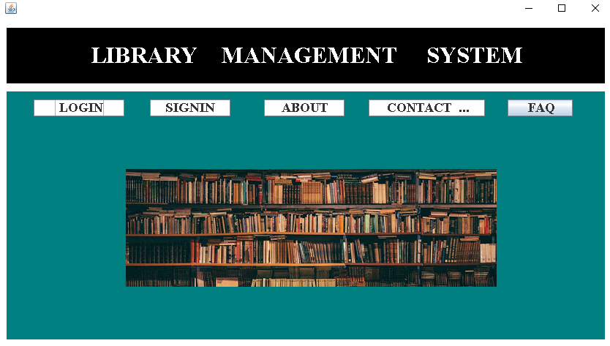

**LOGIN:**

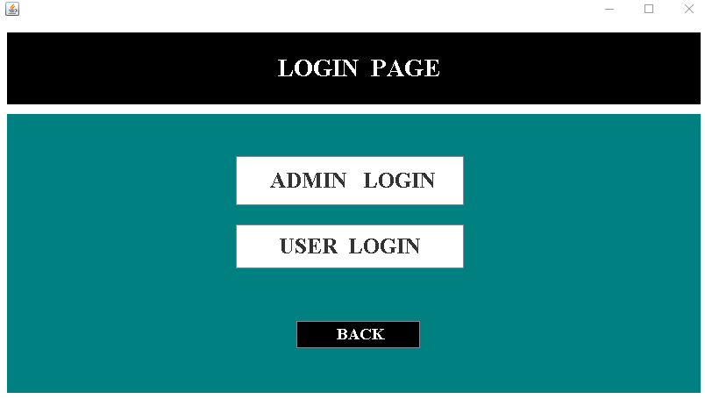

**ADMIN LOGIN PAGE:**

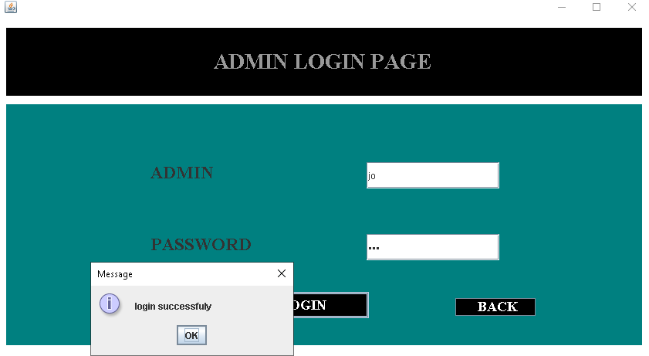

**ADMIN PAGE:**

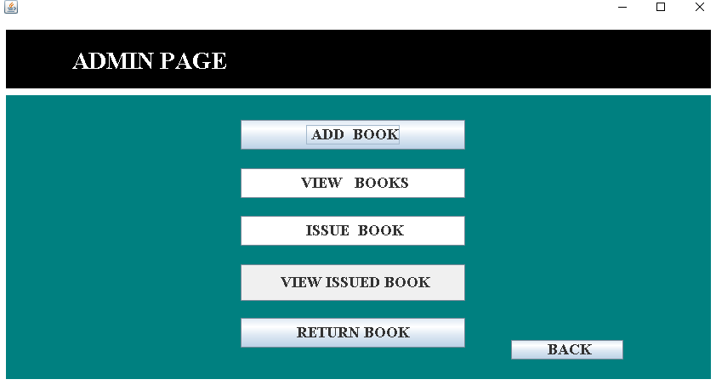

**ADD BOOKS:**

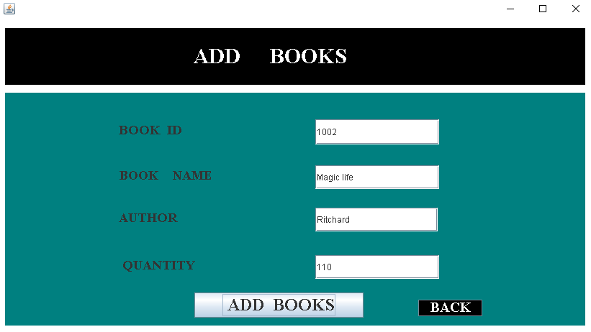

**VIEW BOOK DETIALS:**

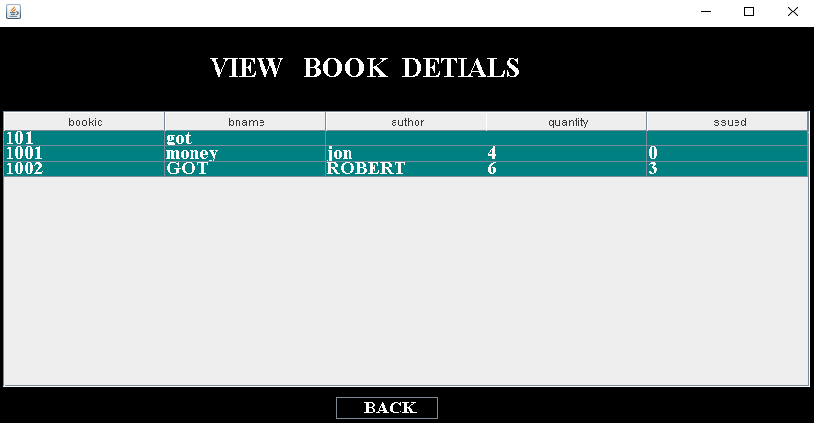

**ISSUED BOOK:** 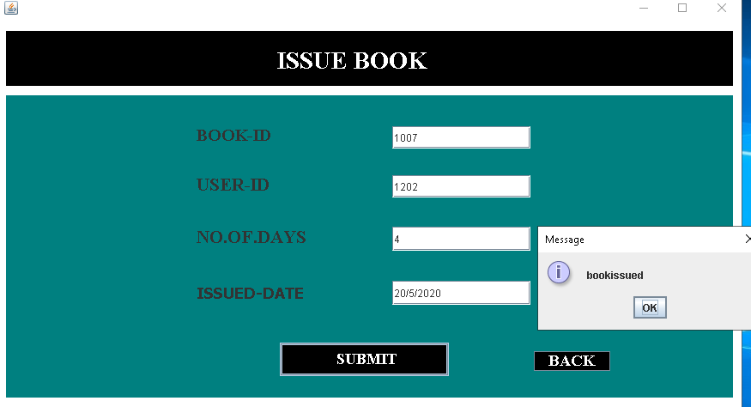

**VIEW ISSUED BOOKS:**

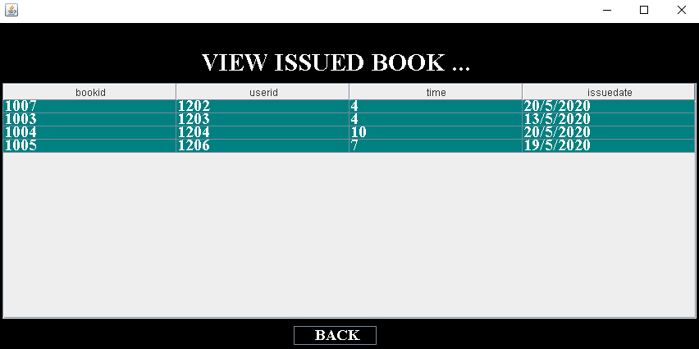

**RETURN BOOKS:**

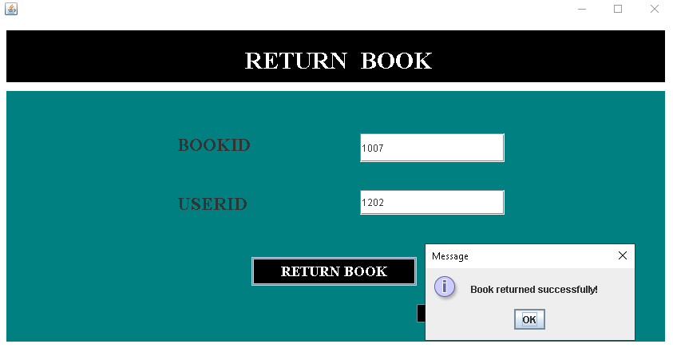

**USER LOGIN:**

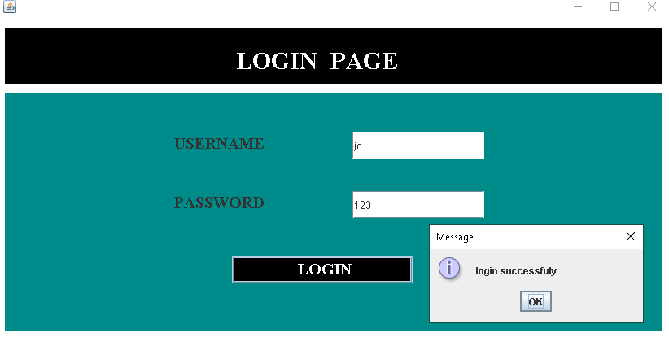

**USERPAGE:**

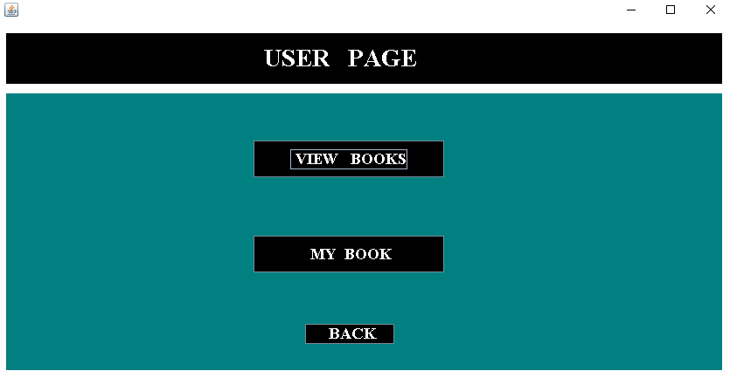

**VIEW BOOKS:**

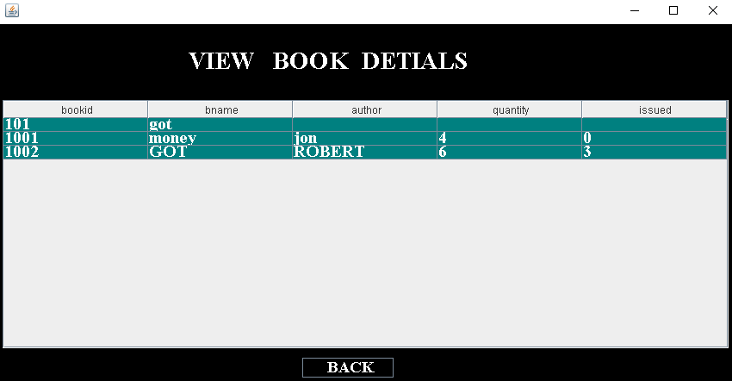

**MY BOOKS:**

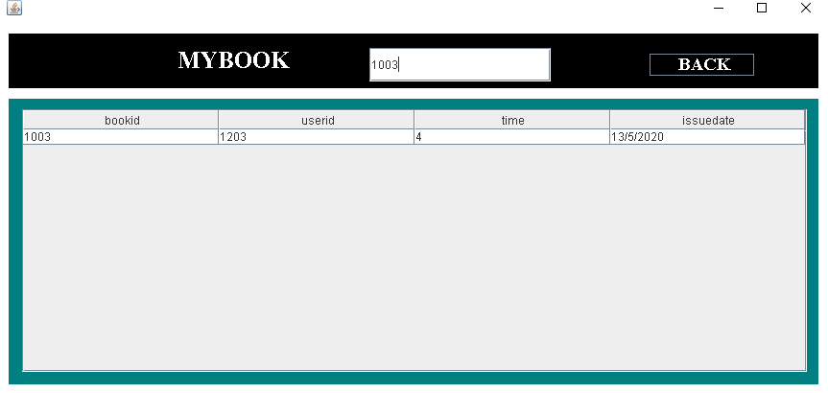

**SIGNUP:**

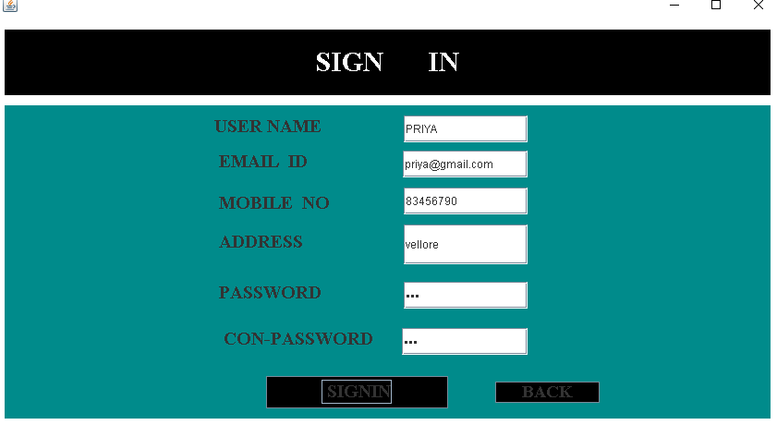

**ABOUT US:**

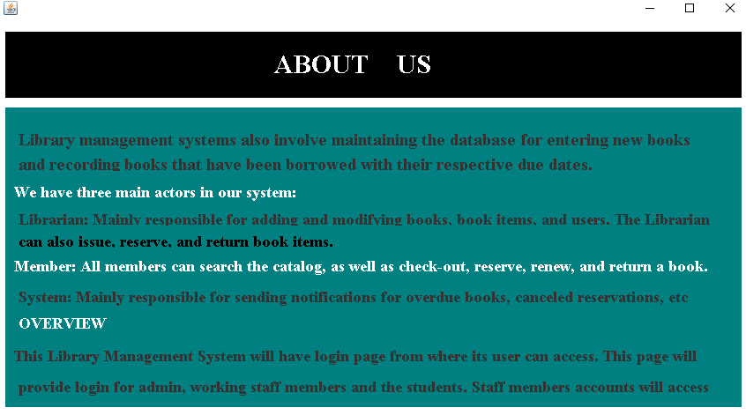

**CONTACT US :**

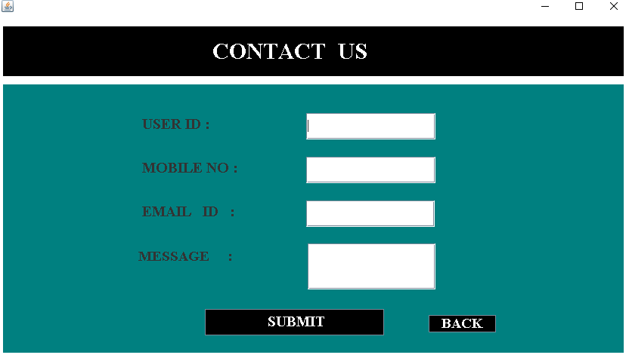

**DATABASE CONNECTIVITY:**

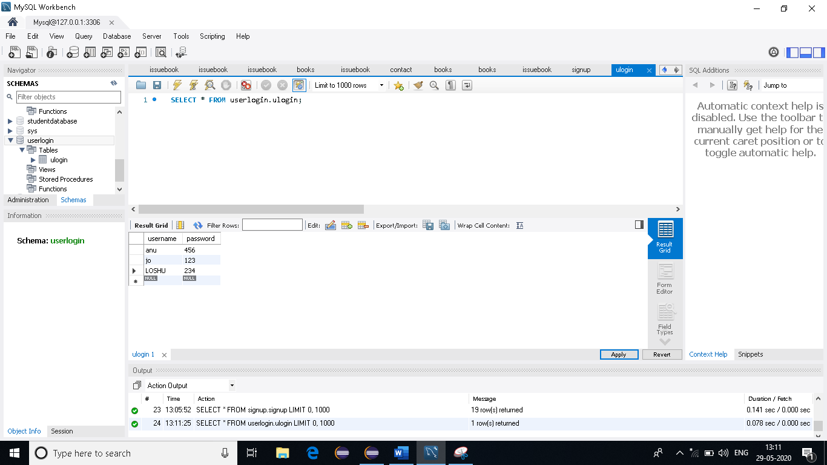

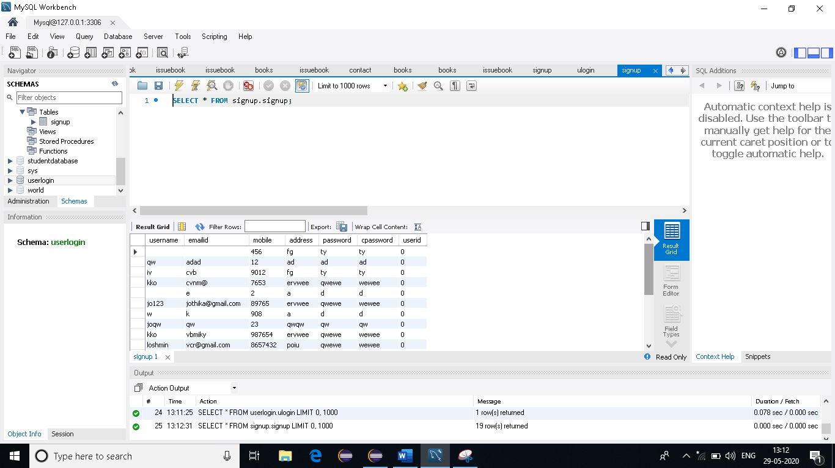

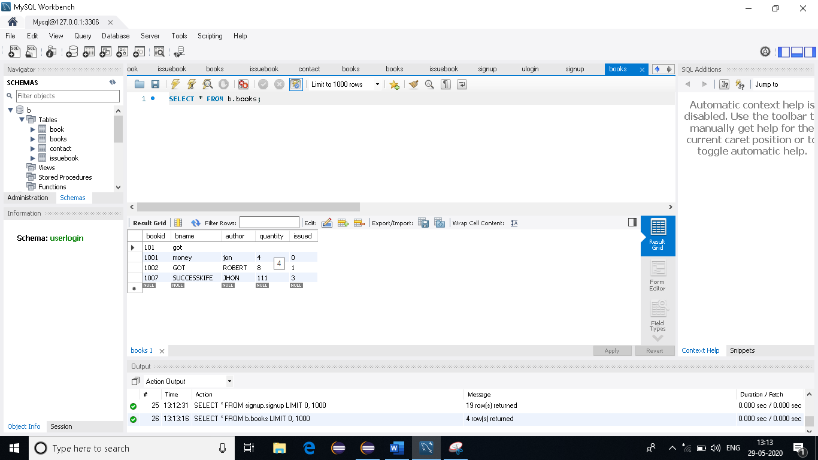

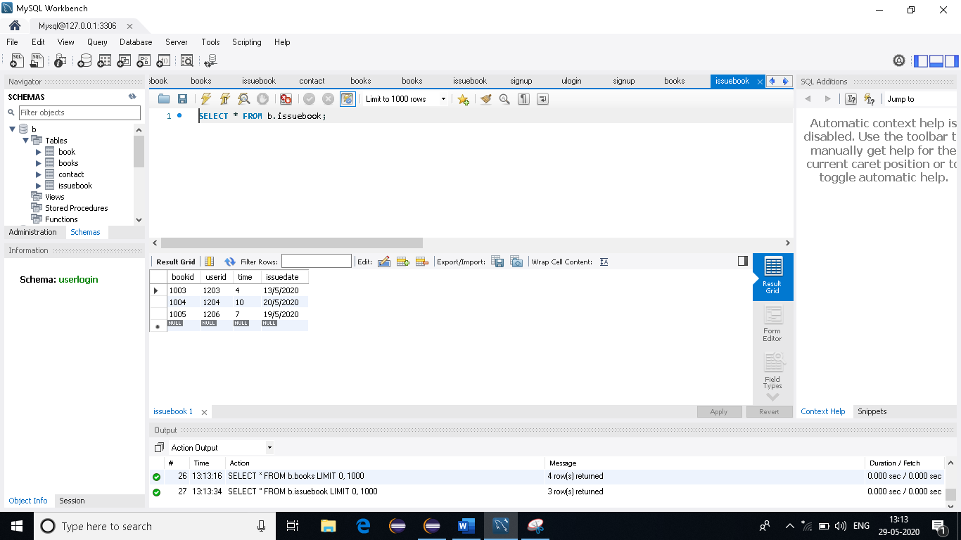

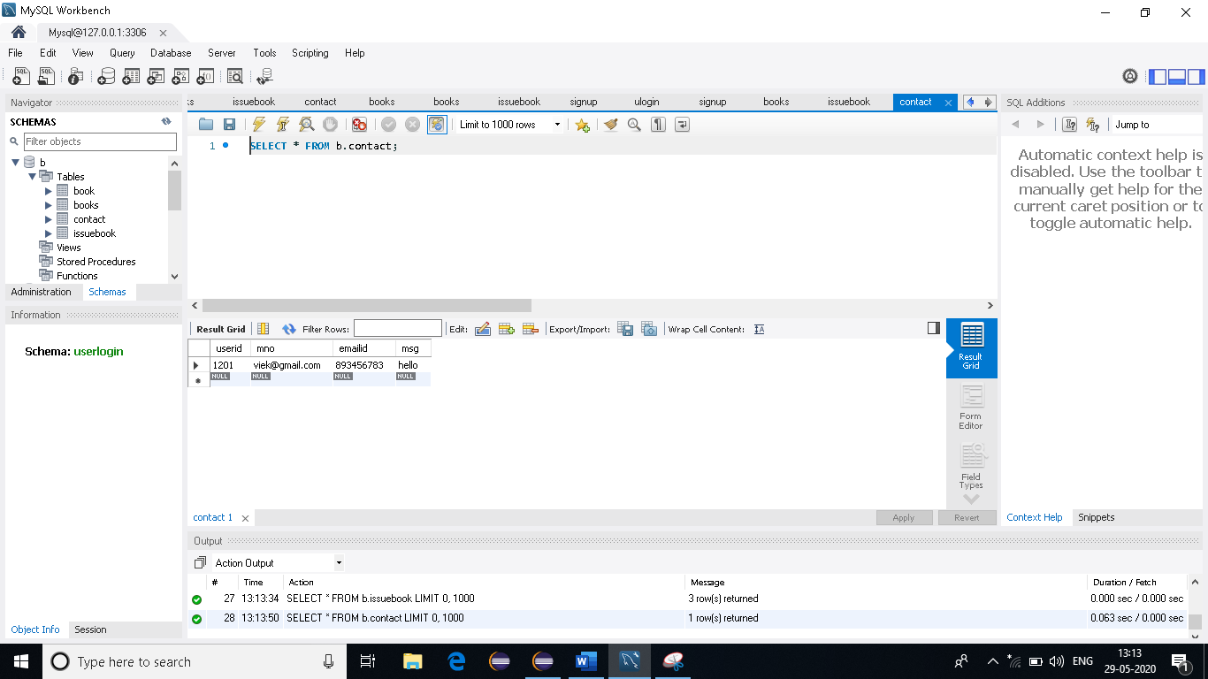

**CONCLUSION:**

* The library management system allows the user to store the book details and the persons details
* The software allows storing the details of all the data related to the library.
* The implementation of the system will reduce data entry time provide readily calculated reports.
* Efficient management of records.
* Portable and flexible for futhur enhancement
* Fast access to database
* User friendly interface